INVITATION FOR BIDS

CEYLON PETROLEUM CORPORATION

Consultancy Services for the project “Construction of a Regasified Liquefied Natural Gas (R-LNG) Pipeline from Floating Storage Regasification Unit (FSRU) located around 5km off the Kerawalapitiya coastal belt to existing and future Kelanitissa and Kerawalapitiya Power Plants”
B/11/2020

Sealed Bids are hereby invited by the Chairman, Department Procurement Committee, on behalf of the Ceylon Petroleum Corporation to obtain consultancy services for the Construction of a Regasified Liquefied Natural Gas (R-LNG) Pipeline from Floating Storage Regasification Unit (FSRU) to be located around 5km off the Kerawalapitiya coastal belt to the existing and future Power Plants at Kelanitissa and Kerawalapitiya.

Bidding documents can be obtained between 0900 hrs. to 1500 hrs. up to 03.04.2020 from the Office of Manager (Procurement & Stores), Ceylon Petroleum Corporation, 1st Floor, No.609, Dr. Danister De Silva Mawatha, Colombo 09, on a written request and on payment of a non-refundable all inclusive fee of Rs. 10,000.00.

The Bid will be closed at 1400 hrs. on 06.04.2020 and opened at the Office of Manager (Procurement & Stores), immediately after closing time of the Bid. Bidders or their authorized representatives will be permitted to be present at the opening of the Bid.

Bids may be sent by post under registered cover or may be deposited in the Tender Box kept in the Office of Manager (Procurement & Stores), Ceylon Petroleum Corporation, 01st Floor, No. 609, Dr. Danister De Silva Mawatha, Colombo 09.

Bidding Documents can be inspected at the Office of Manager (procurement & Stores) from 10.03.2020 within the office hours and up to 1500 hrs. on 03.04.2020. The Bidding Document is also available in the website www.ceypetco.gov.lk for interested bidders.

A Pre-bid meeting has been arranged at 10.00 hrs. on 27.03.2020 in the Premises of Manager (Procurement & Stores) which the address is given below. Interested Bidders are requested to participate for this pre-bid meeting.

Clarifications (if any) shall be sought from the under mentioned Telephone / Fax Numbers

Manager (Procurement & Stores)
Ceylon Petroleum Corporation,
01st Floor,
No. 609, Dr. Danister De Silva Mawatha, Colombo 09.
Tele: 011 5455330, 011 5666225
Fax: 011 5455424

REQUEST FOR PROPOSALS

FOR

Consultancy Services for the project “Construction of a Regasified Liquefied Natural Gas (R-LNG) Pipeline from Floating Storage Regasification Unit (FSRU) located around 5km off the Kerawalapitiya coastal belt to existing and future Kelanitissa and Kerawalapitiya Power Plants”

CEYLON PETROLEUM CORPORATION

Table of Contents
Section 1 - Letter of Invitation

Section 2 - Instructions to Consultants (including Data Sheet)

Section 3 - Technical Proposal - Standard Forms

Section 4 - Financial Proposal - Standard Forms

Section 5 - Terms of Reference

Section 6 - Standard Form of Contract

Section 1- Letter of Invitation

RFP NO:
Date:

Dear Ms.: [insert: Name and Address of shortlisted Consultant]
Consultancy Services for the project “Construction of a Regasified Liquefied Natural Gas (R-LNG) Pipeline from Floating Storage Regasification Unit (FSRU) located around 5km off the Kerawalapitiya coastal belt to existing and future Kelanitissa and Kerawalapitiya Power Plants”

- The Department Procurement Committee (DPC) on behalf of the Ceylon Petroleum Corporation invites proposals to provide the above consultancy services. More details on the required services are indicated in the Terms of Reference attached.
It is not permissible to transfer this invitation to bid to any other Consultancy Organization after the successful assignment.

- A Consultancy Company will be selected under a Quality and Cost Based Selection (QCBS) method and as per the procedures described in this RFP, in accordance with the policies described in the latest version of the “Guidelines for selection and Employment of Consultants”, published by the National Procurement Agency (NPA) of Sri Lanka.

- This RFP includes the following documents:
Section 1 - Letter of Invitation
Section 2 - Instructions to Consultants (including Data Sheet)
Section 3 - Technical Proposal - Standard Forms
Section 4 - Financial Proposal - Standard Forms
Section 5 - Terms of Reference
Section 6 - Standard Form of Contract

- Please inform us in writing at the address given below, upon receipt:
  - That you received this Letter of Invitation; and
  - Whether you will submit a proposal alone or in association.

Yours sincerely,

Chairman
Department Procurement Committee,
C/o Ceylon Petroleum Corporation,
Procurement & Stores Function,
No. 609, Dr. Danister De Silva Mawatha, Colombo 09, Sri Lanka.

Section 2 - Instructions to Consultants

Section 2 - Instructions to Consultants
Definitions | - “Client” means the procuring entity with which the selected Consultant signs the Contract for the Services.  - “Consultant” means any organization that may provide or provides the Services to the “Client” under the Contract.  - “Contract” means the contract signed by the Parties and all the attached documents listed in Clause 1 as the General Conditions (GC), the Special Conditions and the form of agreement.  - “Data Sheet” means such part of the Instructions to Consultants used to reflect specific assignment conditions.  - “Day” means calendar day.  - “Foreign Personnel” means such professionals and support staff who at the time of being so provided had their domicile outside Sri Lanka;  - “Instructions to Consultants” (Section 2 of the RFP) means the document which provides the shortlisted Consultants, with all the information needed by them to prepare their proposals.  - “Local Personnel” means such professionals and support staff who at the time of bidding had their domicile within Sri Lanka.  - “LOI” (Section 1 of the RFP) means the Letter of Invitation being sent by the Client to the shortlisted Consultants.  - “Party” means either or both the “Client” and the “Consultant”, as the context requires.  - “Personnel” means professionals and support staff provided by the Consultant or by any Sub-Consultant, and assigned to perform the Services or any part thereof;  - “Proposal” means the Technical Proposal and the Financial Proposal.

1.Introduction | - “RFP” means the “Request for Proposal” prepared by the Client for the selection of Consultants.  - “Services” means the work to be performed by the Consultant pursuant to the Contract.  - “Similar nature consultancy work” means consultancy work successfully completed by the consultant including but not limited to feasibility study, EIA study/HSIEA study and FEED for Offshore and Onshore RLNG/LNG pipeline project where RLNG/LNG pipeline section had been fallen in a densely populated urban area  - “Sub-Consultant” means any person or entity with whom, the Consultant subcontracts any part of the Services.  - “Terms of Reference” (TOR) means the document included in the RFP as Section 5, which explains the objectives, scope of work, activities, tasks to be performed, respective responsibilities of the Client and the Consultant, and the expected results and deliverables of the assignment.  - The Client named in the Data Sheet will select a consulting firm/organization (the “Consultant”) from Bids received according to the selection criteria in accordance with QCBS selection method, described in the item 5.2 of the Data Sheet.  - The Bidders are invited to submit a “Technical Proposal” and a “Financial Proposal” for consulting services required for the assignment named in the  Phase 1 & Phase II described under the paragraph 1.2 of the Data Sheet. The Proposal will be the basis for contract negotiations, and ultimately for a signed Contract with the selected Consultant.  - Consultants should familiarize themselves with local conditions of the location where the assignment has to be carried out and take them into account in preparing their Proposals. To obtain first-hand information on the assignment and local conditions, Consultants or his authorized representatives are encouraged to visit the Client, before submitting a proposal and to attend a pre-bid meeting if one is specified in the Data Sheet. Attending the pre-bid meeting is mandatory.  Consultants should contact the Client’s representative named in the Data  Sheet, to arrange for their visit or to obtain additional information on the Pre-bid meeting. Consultants should ensure that these officials are advised of the visit in adequate time, to allow them to make appropriate arrangements  - The Client will timely provide at no cost to the Consultants the inputs and facilities specified in the Data Sheet, assist the firm in obtaining licenses and permits needed to carry out the services, and make available relevant project data and reports which are available with the Client.  1.5 Consultants shall bear all costs associated with the preparation and submission of their proposals and contract negotiation. The Client is not bound to accept any proposal, and reserves the right to annul the selection process at any time prior to Contract award, without thereby incurring any liability to the Consultants.

Conflict of  Interest  Conflicting  Activities |  | .  1.6 The Client requires that Consultants provide professional, objective, and impartial advice and at all times hold the Client’s interests paramount, strictly avoid conflicts with other assignments or their own corporate interests, and act without any consideration for future work.  1.6.1 Without limitation on the generality of the foregoing, Consultants and any of their affiliates shall be considered to have a conflict of interest, and shall not be recruited under any of the circumstances set forth below:  (a.) A firm that has been engaged by the Client to provide goods, works or services other than consulting services, and any of its affiliates shall be disqualified from providing consulting services related to those goods, works or services. Conversely a firm hired to provide consulting services and any of its affiliates, shall be disqualified from subsequently providing goods or works or services other than consulting services, resulting from or directly related to the firm’s consulting services.

Conflicting  Assignments  Conflicting relationship | - A Consultant (including its Personnel and Sub-Consultants) or any of its affiliates shall not be hired for any assignment that by its nature, may be in conflict with another assignment of the Consultant to be executed for the same or for another Client. For example, a Consultant hired to prepare engineering design for an infrastructure project shall not be engaged to prepare an independent environmental assessment for the same project. Similarly, a Consultant hired to prepare Terms of Reference for an assignment should not be hired for the assignment in question.  - A Consultant (including its Personnel and Sub-Consultants) that has a business or family relationship with a member of the Client’s staff who is directly or indirectly involved in any part of (i) the reparation of the Terms of Reference of the assignment, (ii) the selection process for such assignment, or  (iii) supervision of the Contract, may not be awarded a Contract.  1.6.2 Consultants have an obligation to disclose any situation of actual or potential conflict, that impacts their capacity to serve in the best interest of their Client, or that may reasonably be perceived as having this effect. Failure to disclose said situations may lead to the disqualification of the Consultant and/or the termination of its Contract.  1.6.3 No agency or current employees of the Client shall work as Consultants Personnel under their own ministries, departments or agencies. Recruiting former government employees of the Client to work for their former ministries, departments or agencies is acceptable provided, no conflict of interest exists. When the Consultant nominates any government employee as Personnel in their technical proposal, such Personnel must have written certification from their government or employer, confirming that they are allowed to work full-time outside of their previous official position. Such certification shall be provided to the Client by the Consultant as part of his technical proposal.

Unfair Advantage  Only one proposal  Proposal  Validity  Eligibility of Sub- Consultants |  | 1.6.4 If a short listed Consultant could derive a competitive advantage from having provided consultancy services related to the assignment in question, the Client shall make available to all shortlisted Consultants together with this RFP, all information in that respect gives such Consultant any competitive advantage over competing Consultants.  1.7 Shortlisted Consultants may only submit one proposal. If a Consultant submits or participates in more than one proposal, such proposals shall be disqualified. However this does not limit the participation of the same Sub Consultant including individual experts, to more than one proposal.  1.8 The Data Sheet indicates how long Consultants’ Proposals must remain valid, after the submission date. During this period, the Consultants shall maintain the availability of professional staff nominated in the Proposal. The Client will make its best effort to complete negotiations within this period. Should the need arise; the Client may request Consultants to extend the validity period of their proposals. Consultants who agree to such extension shall confirm that they maintain the availability of the professional staff nominated in the Proposal, or in their confirmation of extension of validity of the Proposal the Consultants could submit new staff in replacement, which would be considered in the final evaluation for contract award. Consultants who do not agree have the right to refuse to extend the validity of their Proposals.  1.9 In case a shortlisted Consultant intends to associate with Consultants who have not been shortlisted and/or individual expert(s), such other Consultants and/or individual expert(s) shall be subject to the requirements set forth in this RFP.

Fraud and  Corruption  2 .  Clarification and  Amendment of  RFP  Documents | 1.10 The officials of the Procuring Entity, as well as Consultants participating in this consultant selection process, should adhere to the highest ethical standards both during the selection process and throughout the execution of a contract. In pursuance of this policy, the following definitions are given:  - “corrupt practice” means offering, giving, receiving, or soliciting directly or indirectly of anything of value to influence the action of a public official in the selection process or in contract execution;  - “fraudulent practice” means a misrepresentation or omission of facts, in order to influence a selection process or the execution of a contract;  - “collusive practices” means a scheme or arrangement between two or more consultants with or without the knowledge of the PE, designed to establish prices at artificial and noncompetitive levels;  - “coercive practices” means harming or threatening to harm directly or indirectly, persons or their property to influence their participation in a procurement process or affect the execution of a contract.  - Consultants may request a clarification of any of the RFP documents up to the number of days indicated in the Data Sheet before the proposal submission date. Any request for clarification must be sent in writing, to the Client’s address indicated in the Data Sheet. The Client will respond in writing and will send written copies of the response (including an explanation of the query but without identifying the source of inquiry) to all Consultants, who have collected the RFP documents from the Client. Should the Client deem it necessary to amend the RFP as a result of a clarification, it shall do so following the procedure under para. 2.2.  - At any time before the submission of Proposals, the Client may amend the RFP by issuing an addendum in writing. The addendum shall be sent to all  Consultants who have collected the RFP documents from the Client, and will be binding on them.

3 .  Preparation of  Proposals | Consultants shall acknowledge receipt of all amendments. To give Consultants reasonable time in which to take an amendment into account in their Proposals, the Client may if the amendment is substantial, extend the deadline for the submission of Proposals.  3.1 The Proposal (see para. 1.2), as well as all related correspondence exchanged by the Consultants and the Client, shall be written in English Language.  3.2 In preparing their Proposal, Consultants are expected to examine in detail the documents comprising the RFP. Material deficiencies in providing the information requested may result in rejection of a Proposal.  3.3 While preparing the Technical Proposal, Consultants must give particular attention to the following:  - If a shortlisted Consultant considers that it may enhance its expertise for the assignment by associating with other Consultants in a joint venture or sub-consultancy, it may associate with either (a) non short listed Consultant(s), or (b) shortlisted Consultants if so indicated in the Data Sheet. A shortlisted Consultant must first obtain the approval of the Client if it wishes to enter into a joint venture with non-shortlisted or shortlisted Consultant(s). In case of association with non-shortlisted Consultant(s), the shortlisted Consultant shall act as association leader. In case of a joint venture, all partners shall be jointly and severally liable and shall indicate who will act as the leader of the joint venture.  - The estimated number of Professional staff-months or the budget for executing the assignment shall be shown in the Data Sheet, but not both. However, the Proposal shall be based on the number of Professional staff-months or budget estimated by the Consultants. For fixed-budget-based assignments, the available budget is given in the Data Sheet and the Financial Proposal shall not exceed this budget, while the estimated number of Professional staff-months shall not be disclosed.

Technical  Proposal  Format and  Content |  | - Alternative professional staff shall not be proposed, and only one curriculum vitae (CV) may be submitted for each position.  - Documents to be issued by the Consultants as part of this assignment must be in English language only.  3.4 The Technical Proposal shall provide the information indicated in the following paras from (a) to (g) using the attached Standard Forms (Section 3).  - a brief description of the Consultants’ organization and an outline of recent experience of the Consultants and in the case of joint venture for each partner on assignments of a similar nature is required in Form TECH-2 of Section 3. For each assignment, the outline should indicate the names of Sub-Consultants/professional staff who participated, duration of the assignment, contract amount, and Consultant’s involvement. Information should be provided only for those assignments for which the Consultant was legally contracted by the client as a corporation or as one of the major firms within a joint venture. Assignments completed by individual professional staff working privately or through other consulting firms cannot be claimed as the experience of the Consultant or that of the Consultant’s associates, but can be claimed by the professional staff themselves in their CVs. Consultants should be prepared to substantiate the claimed experience in their CVs’ if so requested by the Client.  Comments and suggestions on the Terms of Reference including workable suggestions that could improve the quality/effectiveness of the assignment; and on requirements for counterpart staff and facilities including: administrative support, office space, local transportation, equipment, data, etc. to be provided by the Client (Form TECH-3 of Section 3).

- A description of the approach, methodology and work plan for performing the assignment covering the following subjects: technical approach and methodology, work plan, and organization and staffing schedule. Guidance on the content of this section of the Technical Proposal is provided under Form TECH-4 of Section 3. The work plan should be consistent with the Work Schedule (Form TECH-8 of Section 3) which will show in the form of a bar chart the timing proposed for each activity.

- The list of the proposed professional staff team by area of expertise, the position that would be assigned to each staff team member and their tasks (Form TECH-5 of Section 3).

- Estimates of the staff input (staff-months of foreign and local professionals) needed to carry out the assignment (Form TECH-7 of Section 3). The staff-months input should be indicated separately for foreign (if required) and local professional staff.

- CVs of the professional staff signed by the staff themselves or by the authorized representative of the professional staff (Form TECH-6 of Section 3).

- a detailed description of the proposed methodology and staffing for training, if the Data Sheet specifies training as a specific component of the assignment.

  - The Technical Proposal shall not include any financial information. A Technical Proposal containing financial information may be declared non responsive.

Financial  Proposals  Taxes  4 .  Submission  Receipt, and Opening of  Proposals | - The Financial Proposal shall be prepared using the attached Standard Forms  (Section 4). It shall list all costs associated with the assignment, including  - Remuneration for local and foreign staff (if required);  and  (b) Other expenses indicated in the Data Sheet. If stated in the Data Sheet, these costs should be broken down by activity using FORM FIN – 5 and if appropriate, into foreign and local expenditures. All activities and terms described in the Technical Proposal must be priced separately; activities and items described in the Technical Proposal but not priced shall be assumed to be included in the prices of other activities or items.  3.7 A foreign Consultant may be subject to local taxes on amounts payable by the Client under the Contract. Any such amounts shall not be included in the Financial Proposal as they will not be evaluated, but they will be discussed at contract negotiations and applicable amounts will be included in the Contract. The tax liability of a local Consultant shall be borne by the Consultant.  3.8 The Consultants must price the local cost in Sri Lanka Rupees only. However, the expenditure involves in foreign currency such as foreign consultant’s fees and air ticket may be price in foreign currency.  4.1 The original Proposal (Technical Proposal and Financial Proposal) shall contain no interlineations or overwriting, except as necessary to correct errors made by the Consultants themselves. The person who signed the Proposal must initial such corrections. Submission letters for both Technical and Financial Proposals should respectively be in the format of TECH-1 of Section 3, and FIN-1 of Section 4.  4.2 An authorized representative of the Consultants shall initial all pages of the original Technical and Financial Proposals. The authorization shall be in the form of a written Power of Attorney accompanying the Proposal or in any other form demonstrating that the representative has been dully authorized to sign. The signed Technical and Financial Proposals shall be marked  “ORIGINAL”.  4.3 The Technical Proposal shall be marked “ORIGINAL” or “COPY” as appropriate. The Technical Proposals shall be sent to the addresses referred to in para. 4.5, and the number of copies indicated in the Data Sheet. All required copies of the Technical Proposal shall be made from the original. If there are discrepancies between the original and the copies of the Technical Proposal, the original governs.  4.4 The original and all copies of the Technical Proposal shall be placed in a sealed envelope clearly marked “TECHNICAL PROPOSAL” Similarly the original Financial Proposal shall be placed in a sealed envelope clearly marked “FINANCIAL PROPOSAL” followed by the name of the assignment, and with a warning “DO NOT OPEN WITH THE  TECHNICAL PROPOSAL.” The envelopes containing the Technical and Financial Proposals shall be placed into an outer envelope and sealed. This outer envelope shall bear the submission address, reference number and title, and be clearly marked “DO NOT OPEN, EXCEPT IN PRESENCE OF THE OFFICIAL APPOINTED, BEFORE [insert the time and date of the  submission deadline indicated in the Data Sheet]”. The Client shall not be responsible for misplacement, losing or premature opening, if the outer envelope is not sealed and/or marked as stipulated. This circumstance may become a case for Proposal rejection. If the Financial Proposal is not submitted in a separate sealed envelope duly marked as indicated above, this will constitute grounds for declaring the Proposal as non-responsive.  4.5 The Proposals must be sent to the address indicated in the Data Sheet and received by the Client no later than the time and the date indicated in the Data Sheet or any extension to this date in accordance with para. 2.2. Any proposal received by the Client after the deadline for submission shall be returned unopened.  4.6 The Client shall open the Technical Proposal immediately after the deadline for their submission. The envelopes with the Financial Proposal shall remain sealed and securely stored.

5 .  Proposal  Evaluation  Evaluation of Technical proposals  Public Opening of financial Proposals  (Only for QCBS, FBS and LCS) | 5.1 From the time the Proposals are opened up to the time the Contract is awarded, the Consultants should not contact the Client on any matter related to its Technical and/or Financial Proposal. Any effort by Consultants to influence the Client in the examination, evaluation, ranking of Proposals, and recommendation for award of Contract may result in the rejection of the  Consultants’ Proposal. Evaluators of Technical Proposals shall have no access to the Financial Proposals until the technical evaluation is concluded.  5.2 The Client shall evaluate the Technical Proposals on the basis of their responsiveness to the Terms of Reference, applying the evaluation criteria, sub-criteria, and point system specified in the Data Sheet. Each responsive Proposal will be given a technical score (St). A Proposal shall be rejected at this stage if it does not respond to important aspects of the RFP, and particularly the Terms of Reference or if it fails to achieve the minimum technical score indicated in the Data Sheet.  5.3 After the technical evaluation is completed in accordance with paragraph above, the Client shall notify those Consultants whose Proposals did not meet the minimum qualifying mark or were considered non responsive to the RFP and TOR, that their Financial Proposals will be returned unopened after completing the selection process. The Client shall simultaneously notify in writing the Consultants that have secured the minimum qualifying mark, the date, time and location for opening the Financial Proposals. The opening date should allow Consultants sufficient time to make arrangements for attending the opening. Consultants’ attendance at the opening of Financial Proposals is optional.  5.4 Financial Proposals shall be opened publicly in the presence of the Consultants’ representatives who choose to attend. The name of the Consultants and the technical scores obtained by each qualified Consultant shall be read aloud. The Financial Proposal of the Consultants who met the minimum qualifying mark will then be inspected, to confirm that they have remained sealed and unopened. These Financial Proposals shall be then opened and the total prices read aloud and recorded.

Evaluation of Financial  Proposals for  QBS  Evaluation of  Financial  Proposals  (Only for QCBS, FBS and LCS) | 5.5 Following the ranking of technical Proposals as described under 5.2 above, the Client will examined the Financial Proposal of the first ranked Consultant. First the Client will examine whether the Financial Proposal is complete. Then the Proposal is checked for arithmetical errors. The reasonability of the following in comparison with the supporting documents submitted by the Consultant is examined:  - The remuneration rates, social costs, overheads, profits; and  - Other costs such as out of pocket expenses, cost of surveys, equipment, office rent, supplies, travel, transport, computer rental, mobilization, and printing.  Following the ranking of technical Proposals when selection is based on quality only (QBS), the first ranked Consultant is invited to negotiate its proposal and the Contract in accordance with the instructions given under para. 6 of these Instructions.  5.6 The Evaluation Committee will correct any computational errors. When correcting computational errors in case of discrepancy between a partial amount and the total amount or between word and figures, the former will prevail. In addition to the above corrections as indicated under para. 3.6, activities and items described in the Technical Proposal but not priced, shall be assumed to be included in the prices of other activities or items. In case an activity or line item is quantified in the Financial Proposal differently from the Technical Proposal, (i) if Option B is applicable under Clause 6 of GC, the Evaluation Committee shall correct the quantification indicated in the Financial Proposal so as to make it consistent with that indicated in the Technical Proposal, apply the relevant unit price included in the Financial Proposal to the corrected quantity and correct the total Proposal cost, (ii) if Option A is applicable under Clause 6 of GC, no corrections are applied to the Financial Proposal in this respect. Prices shall be converted to Sri Lankan Rupees if the consultants were allowed to indicate certain expenditure of the Financial Proposal in foreign currency using the selling

Combined  Evaluation of Technical and  Financial  Proposals  (Only for  QCBS)  Evaluation of  Financial  Proposals  (Only for FBS)  Evaluation of  Financial  Proposals  (Only for  LCS)  6 .  Negotiations | rates of exchange, source and date indicated in the Data Sheet.  5.7 In case of QCBS the lowest evaluated Financial Proposal (Fm) will be given the maximum financial score (Sf) of 100 points. The financial scores (Sf) of the other Financial Proposals will be computed as indicated in the Data Sheet. Proposals will be ranked according to their combined technical (St) and financial (Sf) scores using the weights (T = the weight given to the Technical Proposal; P = the weight given to the Financial Proposal;  (T + P = 1) indicated in the Data Sheet: S = St x T% + Sf x P%. The firm achieving the highest combined technical and financial score will be invited for negotiations.  5.8 In the case of Fixed-Budget Selection, the Client will select the firm that submitted the highest ranked Technical Proposal within the budget. Proposals that exceed the indicated budget will be rejected. The evaluated proposal price according to para. 5.6 shall be considered and the selected firm is invited for negotiations.  5.9 In the case of the Least-Cost Selection, the Client will select the lowest Proposal among those that passed the minimum technical score. The evaluated proposal price according to para. 5.6 shall be considered and the selected firm is invited for negotiations  6.1 Negotiations will be held at the date and address indicated in the Data Sheet. The invited Consultant will as a pre-requisite for attendance at the negotiations, confirm availability of all professional staff. Failure in satisfying such requirements may result in the Client proceeding to negotiate with the next-ranked Consultant. Representatives conducting negotiations on behalf of the Consultant must have written authority to negotiate and conclude a Contract.  6.2 Negotiations will include a discussion of the Technical Proposal, the proposed technical approach and methodology, work plan, and organization

Technical  Negotiations  Availability of  Professional  Staff / experts  Financial negotiations  (Only for QCBS, FBS and LCS)  Financial negotiations (Only for  QBS) |  | and staffing, and any suggestions made by the Consultant to improve the Terms of Reference. The Client and the Consultants will finalize the Terms of Reference, staffing schedule, work schedule, logistics, and reporting.  These documents will then be incorporated in the Contract as “Description of Services”. Special attention will be paid to clearly defining the inputs and facilities required from the Client to ensure satisfactory implementation of the assignment. The Client shall prepare minutes of negotiations which will be signed by the Client and the Consultant.  6.3 Having selected the Consultant on the basis of among other things an evaluation of proposed Professional staff, the Client expects to negotiate a Contract on the basis of the professional staff named in the Proposal. Before contract negotiations, the Client will require assurances that the professional staff will be actually available. The Client will not consider substitutions during contract negotiations unless both parties agree that undue delay in the selection process makes such substitution unavoidable or for reasons such as death or medical incapacity. If this is not the case and if it is established that professional staff were offered in the proposal without confirming their availability, the Consultant may be disqualified. Any proposed substitute shall have equivalent or better qualifications and experience than the original candidate, and be submitted by the Consultant within the period of time specified in the letter of invitation to negotiate.  6.4 In the cases of QCBS, FBS, and the LCS methods, unless there are exceptional reasons, the remuneration rates for staff and other proposed unit rates of the financial negotiations shall not be negotiated.  6.5 For QBS method if requested by the Client, the Consultants shall provide the information on remuneration rates described in the Appendix attached to  Section 4 - Financial Proposal - Standard Forms of this RFP
Conclusion  of the negotiations  - .  Award of  contract  - .  Confidentiality |  | 6.6 Negotiations will conclude with a review of the draft Contract. To complete negotiations the Client and the Consultant will initial the agreed Contract. If negotiations fail, the Client will invite the Consultant whose Proposal received the second highest score to negotiate a Contract.  7.1 After completing negotiations the Client shall award the Contract to the selected Consultant, and promptly notify all other Consultants who have submitted proposals. After Contract signature the Client shall not open Financial Proposals of the unsuccessful Consultants.  7.2 The Client will notify the selected Consultant the date, time and venue for the signing of the agreement following the template given in Section 6. The option selected for the method of payment under GC Clause 6 is stated in the Data Sheet.  7.3 The Consultant is expected to commence the assignment on the date and at the location specified in the Data Sheet.  8.1 Information relating to evaluation of Proposals and recommendations concerning awards, shall not be disclosed to the Consultants who have submitted the Proposals or to other persons not officially concerned with the process, until the publication of the award of Contract. The undue use by any Consultant of confidential information related to the process may result in the rejection of its Proposal, and may be subject to the provisions of the Bank’s antifraud and corruption policy.

Instructions to Consultants

DATA SHEET
Paragraph Reference
1.1 | Name of the Client : Ceylon Petroleum Corporation  Method of selection: Quality and Cost Based Selection (QCBS)
1.2 | The assignment is to provide consultancy services for the following main requirements;  - To review and update the existing feasibility study carried out by CEB for the overall purpose including the deployment of a FSRU and Mooring system and provide CPC with the completed feasibility study report for the proposed pipeline.  - To conduct a Health, Safety & Environment Impact Assessment (HSEIA) complying with Asia Development Bank guidelines for the pipeline route and corridors and obtain the necessary approvals from relevant agencies.  - To develop Basic Design and Engineering Package (BDEP) for the project and generate complete input specifications to the Front End Engineering Design (FEED)  - To prepare two separate sets of Bidding documents on EPC/Turnkey and BOT basis adhering to Asia Development Bank (ADB) guidelines  The role of the Project Management Consultancy consists of followings as a minimum requirement but not limited to,  - develop the overall project implementation plan  - manage the development of the project cost estimate  - set up and manage the Consultancy Team consisting of the following personnel as a minimum,  - Senior Consultant – LNG Value Chain  - Lead Design Engineer – Mechanical & Process  - Lead Engineer – Electrical & Instrument  - Lead Engineer – Geotechnical  - Land Surveyor  - Sociology specialist  - Legal Expert  - Project Health, Safety & Environment Specialist (PHSES)  - develop Basic Design and Engineering Package (BDEP) for the project and generate complete input specifications to the Front End Engineering Design (FEED)  - conduct a Health, Safety & Environment Impact Assessment (HSEIA) complying with Asia Development Bank guidelines for the pipeline route and corridors and obtain the necessary approvals from relevant agencies but not limited to Central Environmental Authority (CEA), Coast Conservation Department (CCD), Marine Environmental Protection Authority (MEPA), Road Development Authority (RDA), Urban Development Authority (UDA), Department of Wildlife Conservation, Land Commissioner General’s Department, Sri Lanka Land Reclamation & Development Corporation (SLLRDC), Department of Archaeological, Local Authorities etc. and propose mitigation actions if required.  - Co-ordinate and liaise with all government agencies and regulators to identify and obtain the necessary approvals and licenses necessary for ensuring compliance with Sri Lankan and International regulations, standards, conventions and protocols on behalf of the CPC.  - carryout topographical survey, geotechnical survey and other essential surveys along the selected subsea and onshore sections of the pipeline route.  - finalize the pipeline route and pipeline corridors after identifying the crossings encountered by the pipeline and access areas for construction equipment, plant and materials for both the subsea and onshore sections of the pipeline with due consideration for social and environmental safeguards (even with deviations to the pipeline route proposed by CPC if necessary due to possible social impacts).  - review and update the existing feasibility study carried out by CEB for the overall purpose including the deployment of a FSRU and Mooring system and provide CPC with the completed feasibility study report for the proposed pipeline.  - identification of all the possible and economical construction methodologies for all the proposed developments and obtain the approval of all the stakeholders.  - prepare a project budget to an accuracy of +/- 20%, taking in to consideration of all mechanical, electrical, control and instrumentation and corrosion protection requirements.  - Develop two separate sets of Bidding Documents complying with Asia Development Bank (ADB) Guidelines for the selection of a contractor on;  - EPC/Turnkey basis as per the conditions stipulated in the International Federation of Consulting Engineers (FIDIC)  - Build Operate Transfer (BOT) basis for construction of a Regasified Liquefied Natural Gas (R-LNG) Pipeline from Floating Storage Regasification Unit (FSRU) located around 5km off the Kerawalapitiya coastal belt to existing and future Kelanitissa and Kerawalapitiya Power Plants.  - provide all necessary assistance to CPC for the pre-bid meeting in connection with the EPC/Turnkey contractor / or the project proponent selection and to prepare proper answers for the clarifications raised by the interested parties at the bidding stage.  - provide all necessary technical assistance to CPC at the bid evaluation stage.

1.3 | A pre-bid meeting will be held: Yes [as indicated in Invitation For Bids]  Attendance is preferred.  Venue: Ceypetco House, Ceylon Petroleum Corporation, 609, Dr. Danister de Silva Mawatha, Colombo 09  The Client’s representative is: Deputy General Manager (TS & CA)  Address: Ceypetco House, Ceylon Petroleum Corporation, 609, Dr. Danister de Silva Mawatha, Colombo 09  Telephone: +94 (0)11 5455290 ; Facsimile: +94 (0)11 5455432 E-mail: dammika@ceypetco.gov.lk
1.4 | The Client will provide necessary assistance in obtaining security permits & approvals. Client will assist and coordinate in obtaining any other information from outside organizations, departments etc. Client will provide whatever available data and information required for conducting the relevant assessments.
1.8 | Proposals must remain valid for 90 days from the date of opening of Bids.
1.12 | Consultants, their Sub-Consultants, and their associates shall not be under a declaration of ineligibility for corrupt and fraudulent practices issued by the Bank in accordance with the para. 1.10. Furthermore the Consultants shall be aware of the provisions on fraud and corruption stated in the specific clauses in the General Conditions of Contract.
1.13 | Consultants shall furnish information on commissions and gratuities if any, paid or to be paid to agents relating to this proposal and during execution of the assignment, if the Consultant is awarded the Contract as requested in the Financial Proposal submission form (Section 4).
1.14 | Goods supplied and Consulting Services provided under the Contract may originate from any country except if:  - as a matter of law or official regulation, the Government prohibits commercial relations with that country; or  - that country does not come under the sanctions imposed by United States of America  - by an act of compliance with a decision of the United nations Security Council taken under Chapter VII of the Charter of the United Nations, the Government prohibits any imports of goods from that country or any payments to persons or entities in that country.
2.1 | Clarifications may be requested not later than 07 days before the submission date.  The address for requesting clarifications is: Please refer to Invitation For Bids  Facsimile: +94 (0)11 5455424  E-mail: rajapakse@ceypetco.gov.lk
3.3 (a) | Shortlisted Consultants may associate with other shortlisted Consultants: No
3.3(b) | A: If QCBS/QBS/LCS methods are used: QCBS method will be used  B:The available budget is: To be advised later
3.4(g) | Training is a specific component of this assignment: No
3.6 | Other Expenses: Consultant has to bear

3.6 | Breakdown cost of Activities required?: Yes
4.3 | Consultant must submit the following documents in two separate envelopes. (i.) original and one (01) copy of Technical Proposal
 | (ii.) the original of the Financial Proposal
4.5 | The Proposal submission address is:  Manager (Procurement & Stores)  Ceylon Petroleum Corporation  No: 609  Dr. Danister de Silva Mawatha Colombo 09.  Proposals must be submitted no later than the following date and time:  30/03/2020 1400 hrs
5.2 | Criteria, sub-criteria, and point system for the evaluation of Technical Proposals are:  Points  Criteria Sub-criteria Max. point Min. point  Specific project experience of the Consultants for the last ten (10) years Similar nature consultancy work for Offshore and Onshore RLNG/LNG pipeline project successfully carried out where RLNG/LNG pipeline section had been fallen in a densely populated urban area [points: 25 each] 50 35*  Consultancy work for Offshore and Onshore RLNG/LNG pipeline project successfully carried out  [points: 20 each]  Consultancy work for Offshore RLNG/LNG pipeline project successfully carried out  [points: 10 each]  Consultancy work for Onshore RLNG/LNG pipeline project successfully carried out in a densely populated urban area  [points: 10 each]  Consultancy work for Onshore RLNG/LNG pipeline project successfully carried out  [points: 5 each]  Methodology and Work plan Technical approach and methodology [points: 02] 05 02  Work plan  [points: 02]  Organization and staffing  [points: 01]  Key professional staff qualifications and competence for the assignment *** Senior Consultant – LNG Value Chain [points: 04] 15 10  Lead Design Engineer – Mechanical & Process [points: 03]  Lead Engineer – Electrical & Instrument  [points: 02]  Lead Engineer – Geotechnical  [points: 02]  Project Health, Safety & Environment Specialist (PHSES)  [points: 1.5]  Legal Expert  [points: 01]  Sociology specialist  [points: 01]  Land Surveyor  [points: 0.5]  Permanent presence in Sri Lanka 05 00  Consultancy services related to pipeline projects Feasibility study on Petroleum or Petro Chemical pipeline project [points: 06] 20 06  Environmental Impact Assessments on Petroleum or Petro Chemical pipeline project  [points: 10]  Front End Engineering Design (FEED) on Petroleum or Petro Chemical pipeline project  [points: 08]  Donor funded project experience Consultancy experience on supporting ADB, World Bank, JAICA, IMF funded infrastructure development projects [points: 02 each] 05 00  Total points 100 **  The minimum technical score (St) required to pass is: 65 Points
Notes:
* - to qualify under the ‘Specific project experience of the Consultants’, consultancy works completed shall be in both offshore and on shore sectors.
** - Minimum points to be achieved for eligibility of Technical Proposal/Bid is 65 points out of 100.
*** - Please refer the Sub Heading (d) Competency Requirements of Section 5- Terms of Reference of this document.
5.6 | For the conversions to Sri Lankan Rupees:  The source of official selling rates is: ----------------------------------  The date of exchange rates is: ---------------------------------
5.7 | The formula for determining the financial scores is the following:  Sf = 100 x Fm / F, in which “Sf” is the financial score, “Fm” is the lowest price  and “F” the price of the proposal under consideration. The weights given to the  Technical and Financial Proposals are: T =0.85, and P = 0.15  T+P=1
6.1 | Expected date and address for contract negotiations: Will be informed later
7.2 | The option applicable is : Option A
7.3 | Expected date for commencement of consulting services : Will be informed later
9 | Period of the Contract: Period of this contract is Two Hundred and forty (240) days from the date of receipt of the official Purchase Order to the selected consultant.

Section 3 - Technical Proposal

Standard Forms for Technical Proposal
TECH-1 | Technical Proposal Submission Form
TECH-2 | Consultant’s Organization and Experience  - Consultant’s Organization  - Consultant’s Experience
TECH-3 | Comments or Suggestions on the Terms of Reference and on Counterpart Staff and Facilities to be provided by the Client  - On the Terms of Reference  - On the Counterpart Staff and Facilities
TECH-4 | Description of the Approach, Methodology and Work Plan for Performing the Assignment
TECH-5 | Team Composition and Task Assignments
TECH-6 | Curriculum Vitae (CV) for Proposed Professional Staff
TECH-7 | Staffing Schedule
TECH-8 | Work Schedule

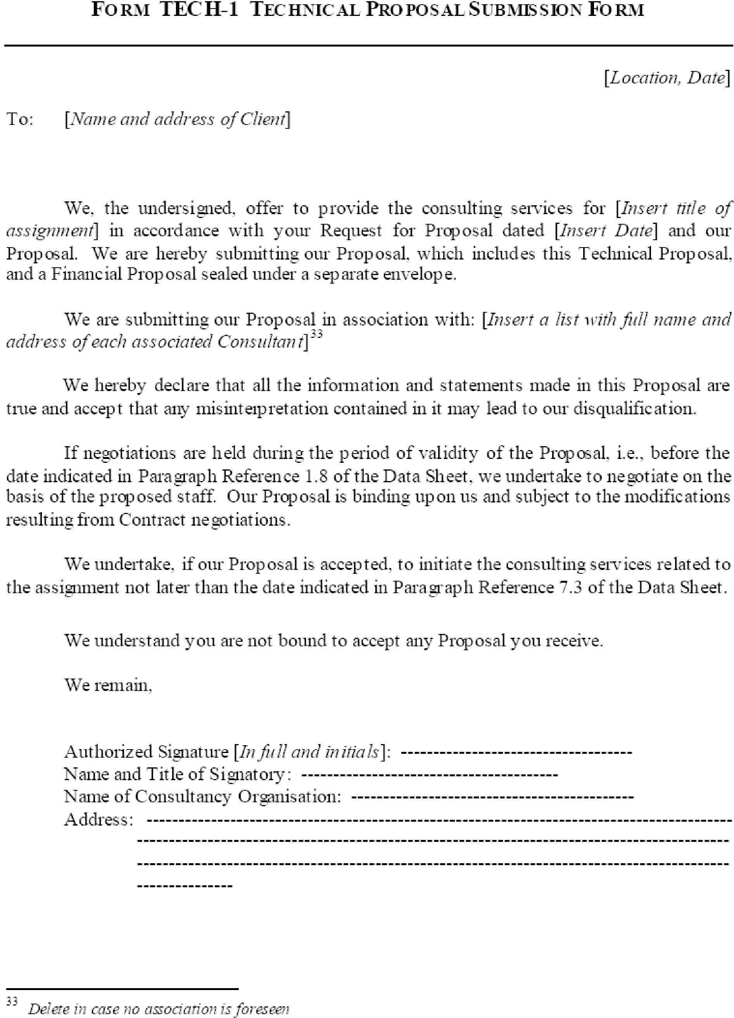

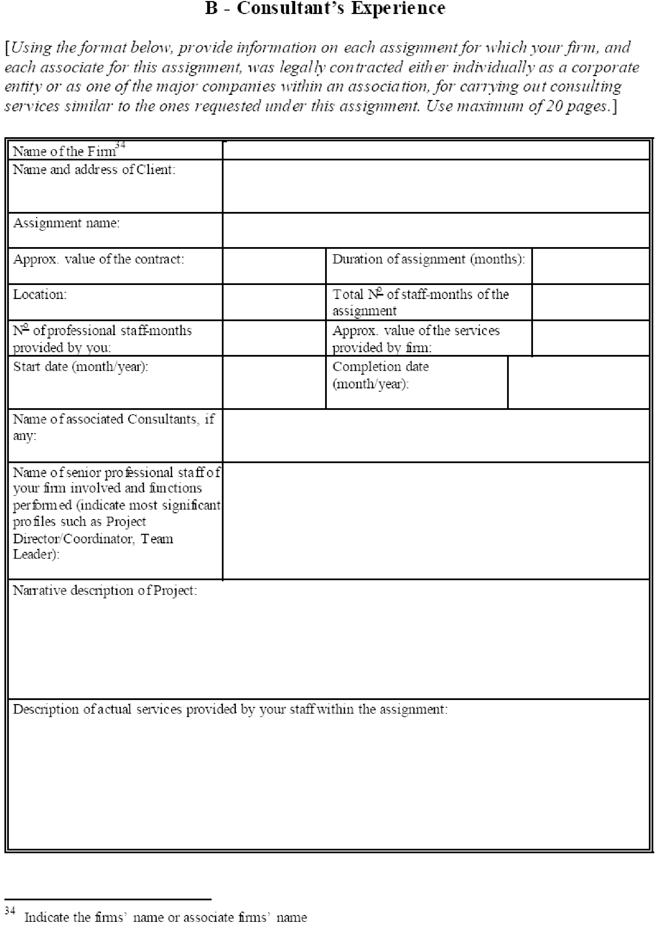

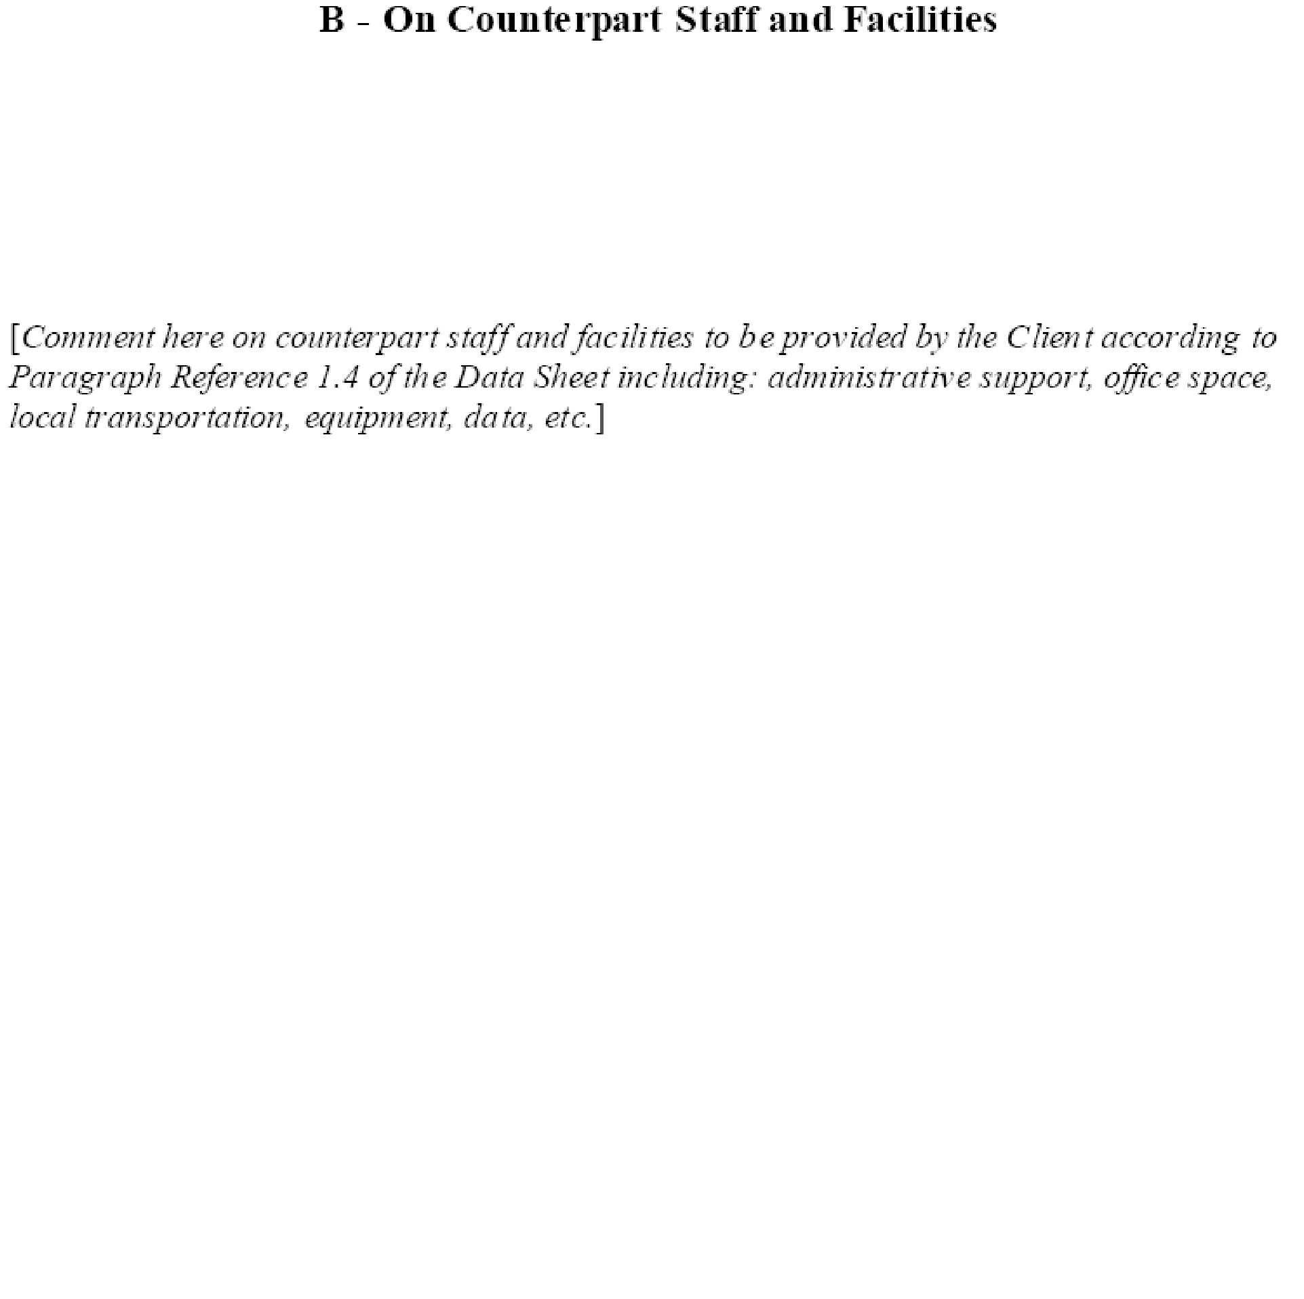

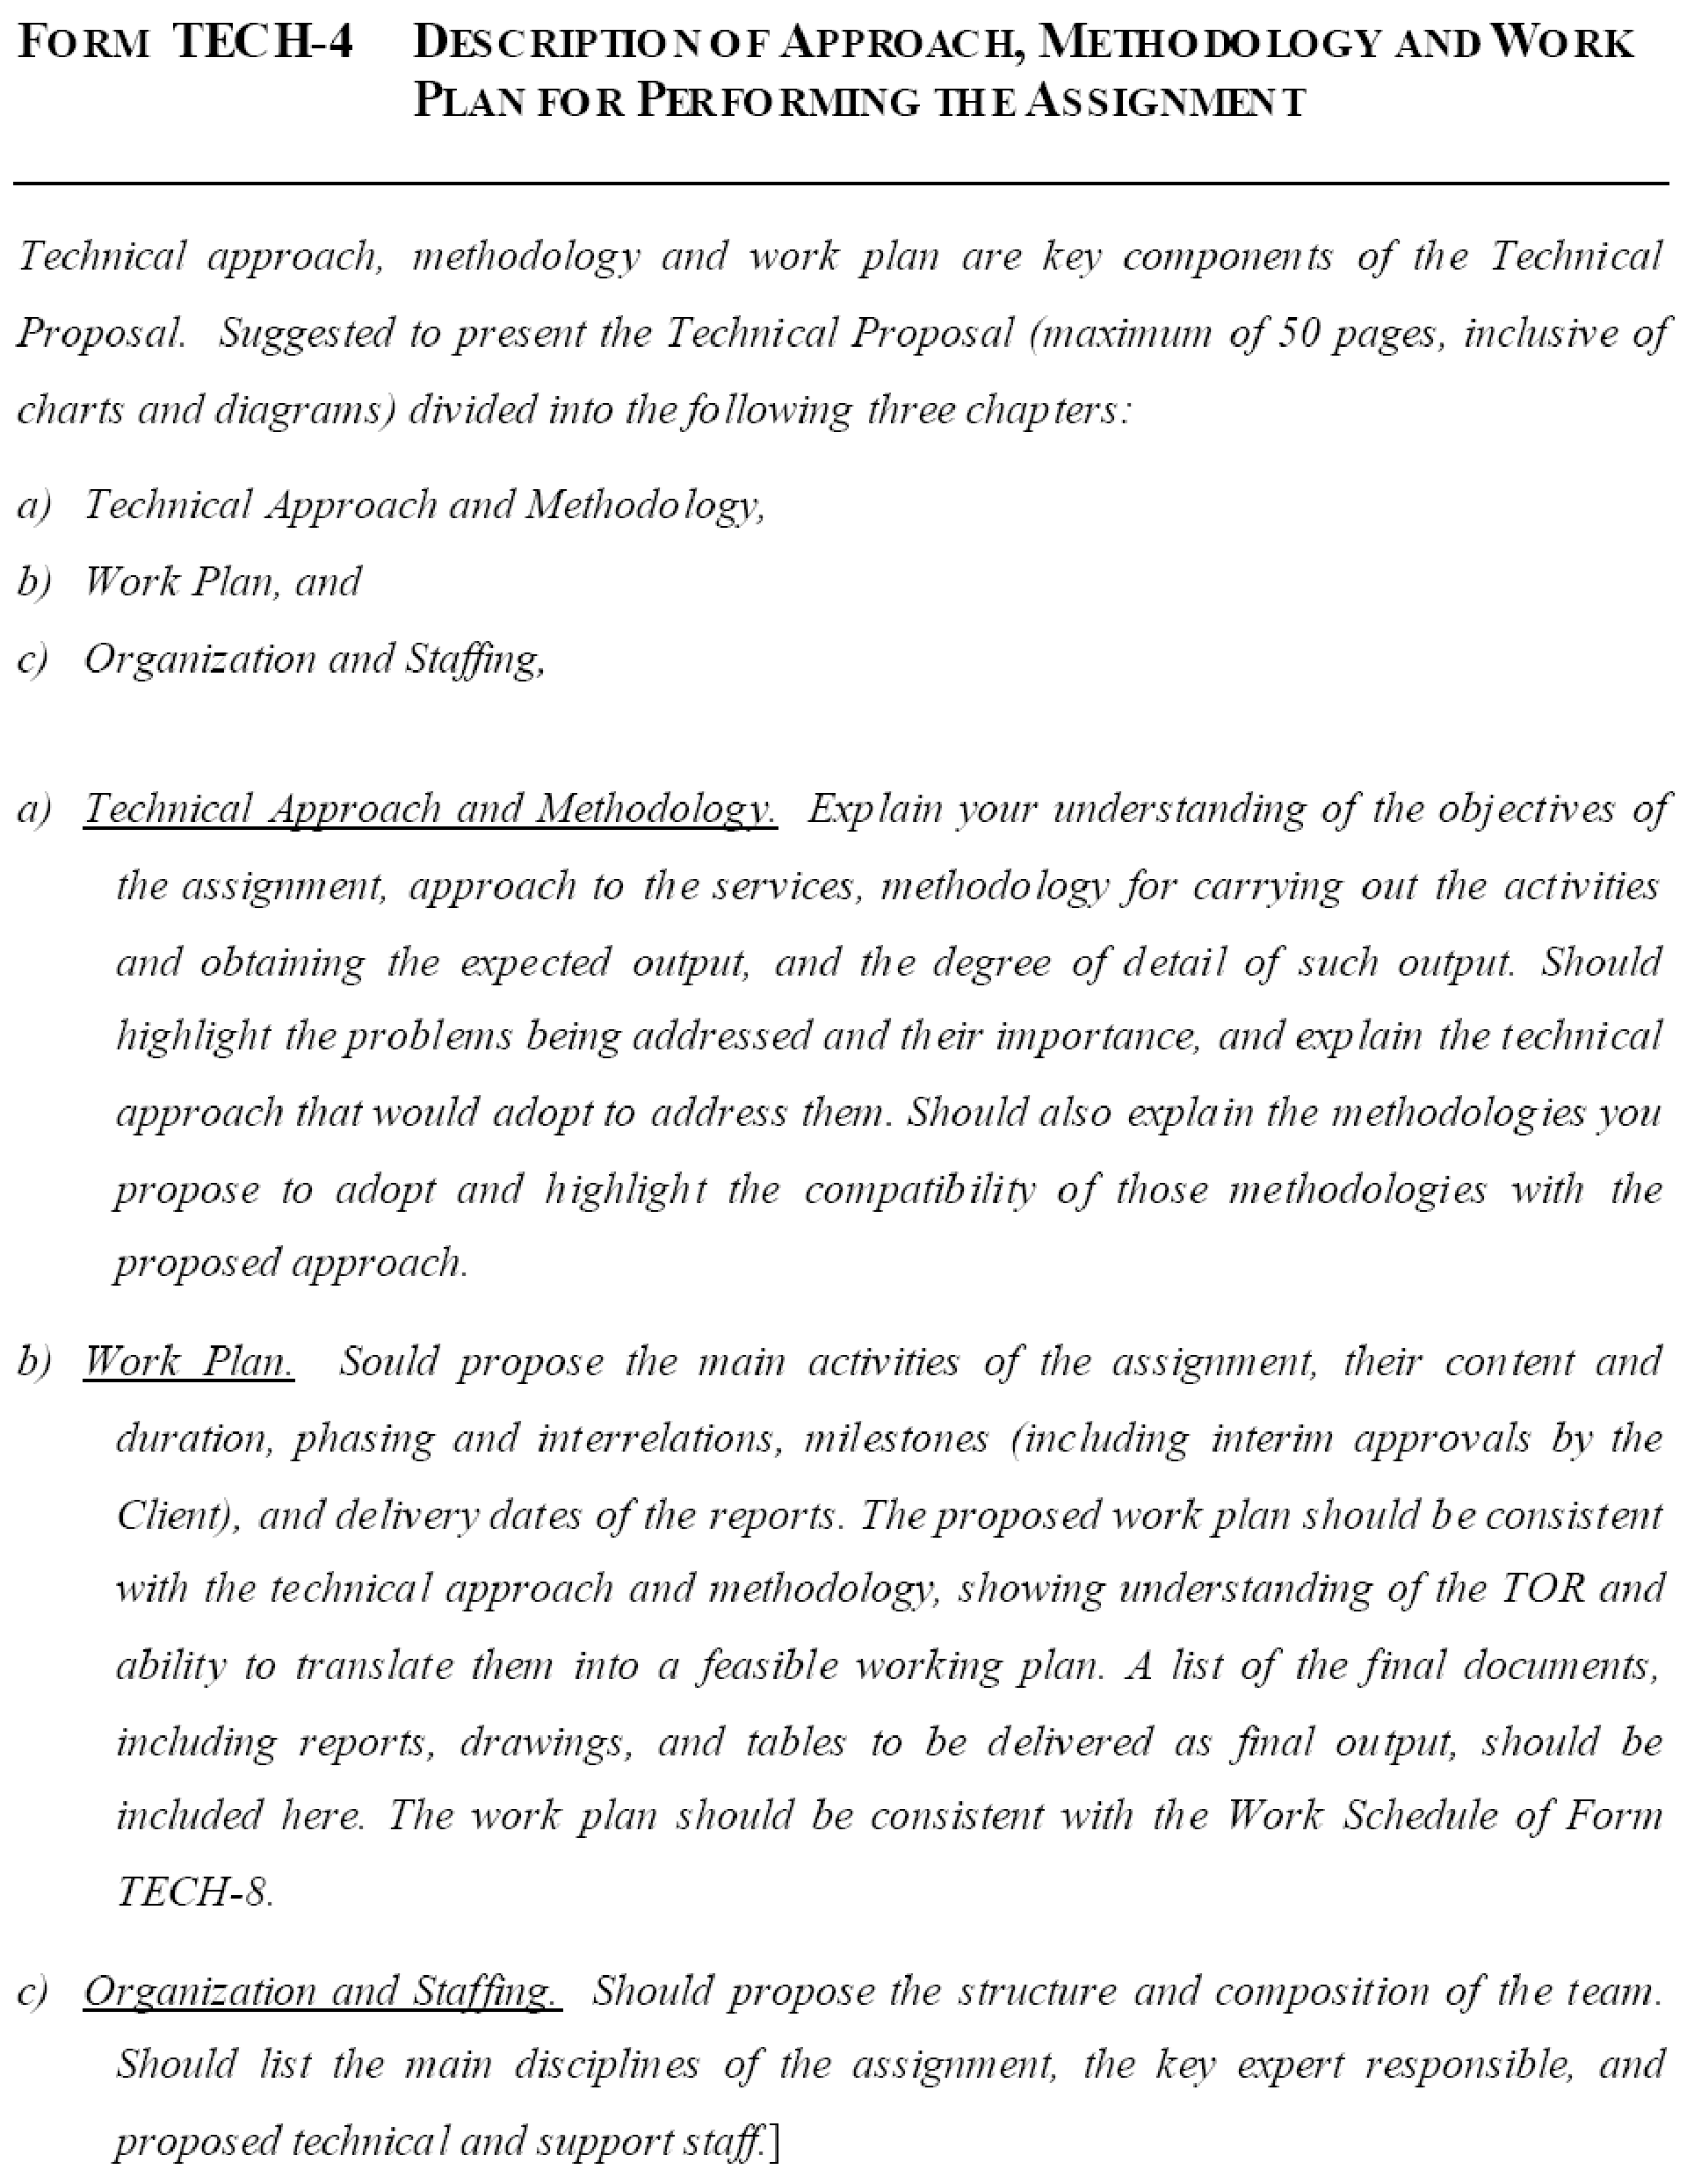

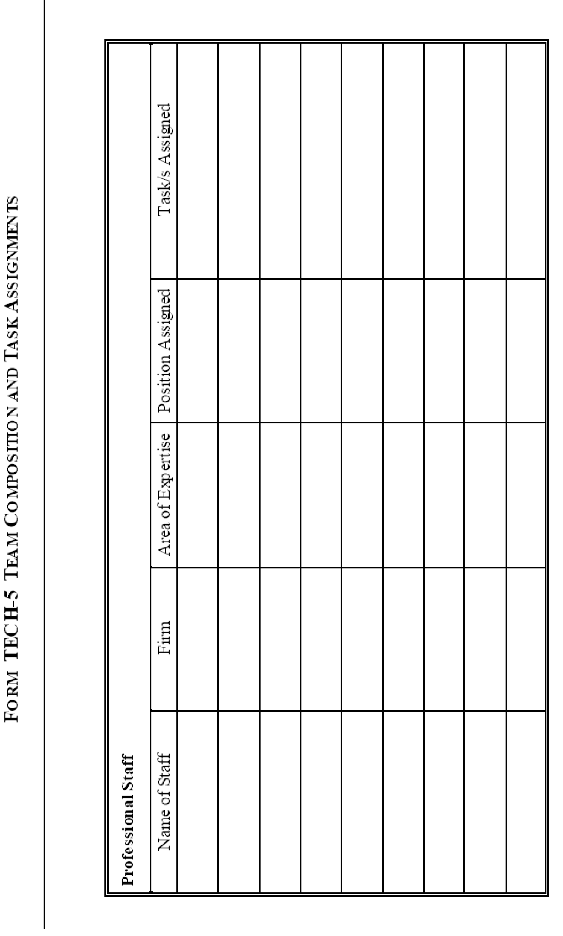

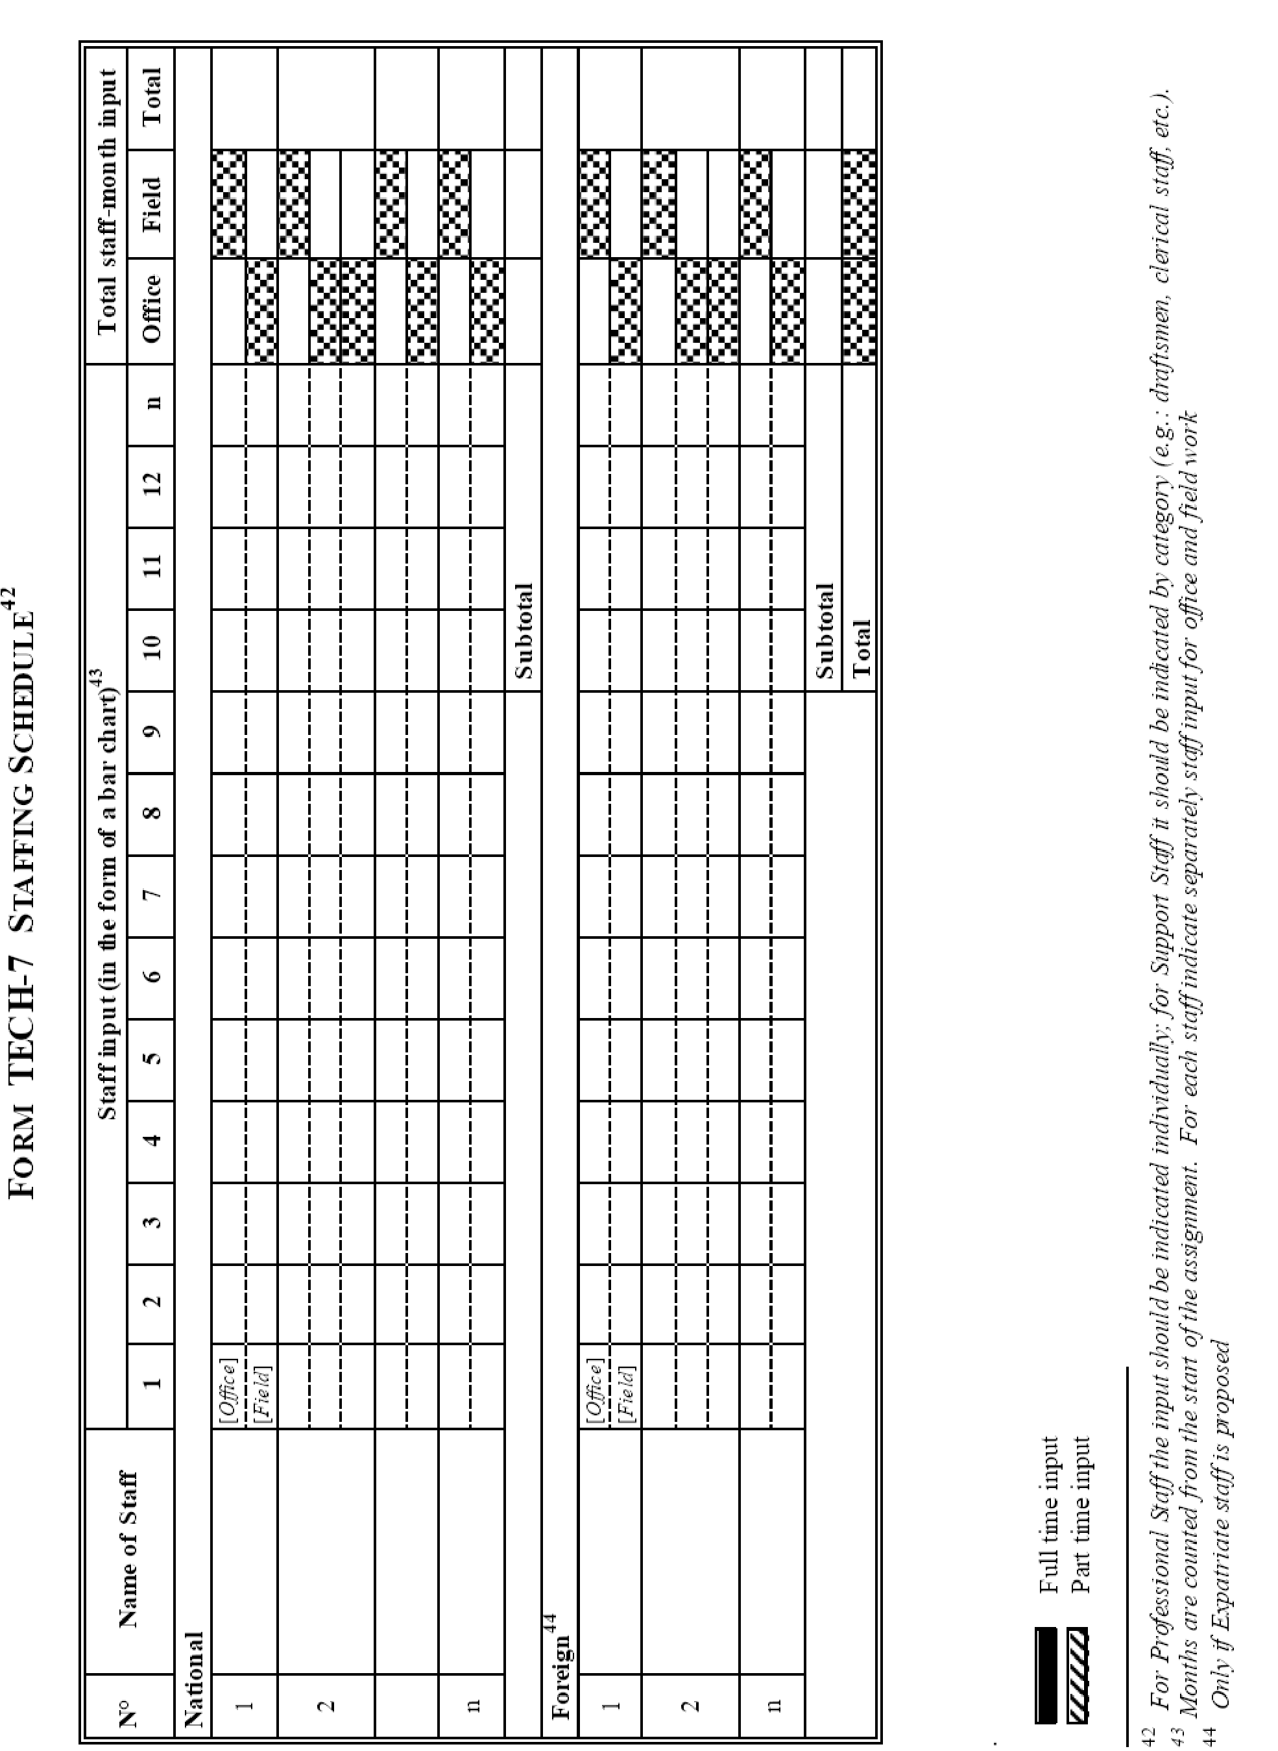

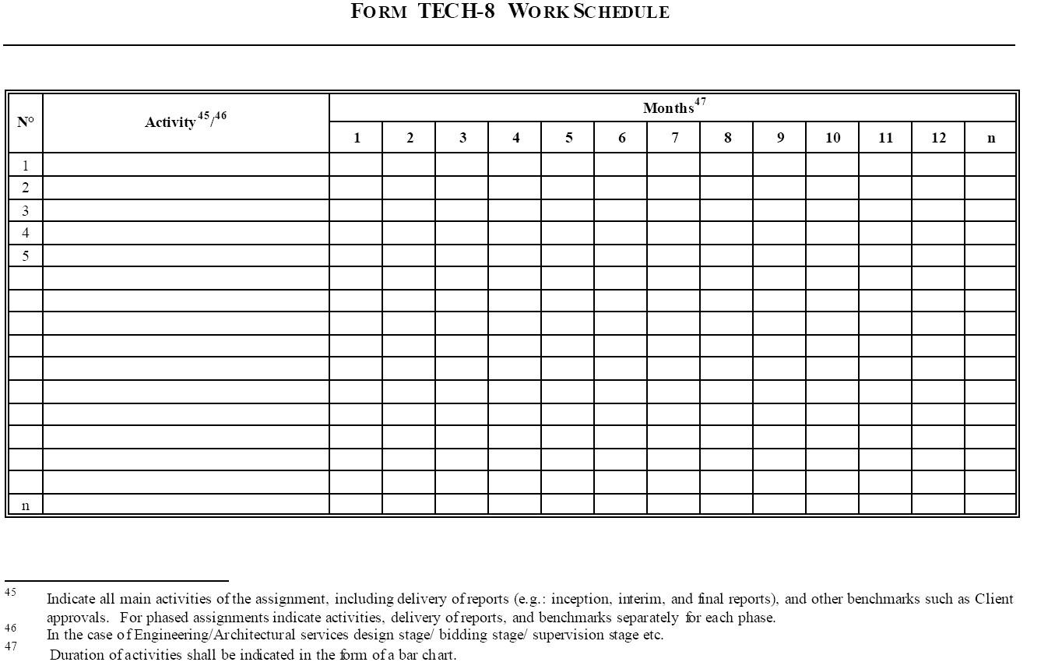

Section 4 - Financial Proposal

Standard Forms for Financial Proposal
FIN-1 Financial Proposal Submission Form

FIN-2 Summary of Costs

FIN-3 Breakdown of Remuneration

FIN-4 Reimbursable expenses

FIN-5 Breakdown of Costs by Activity (if requested under Clause 3.6 of Data Sheet)

Appendix: Financial Negotiations - Breakdown of Remuneration Rates
( for Quality Based Selection only)

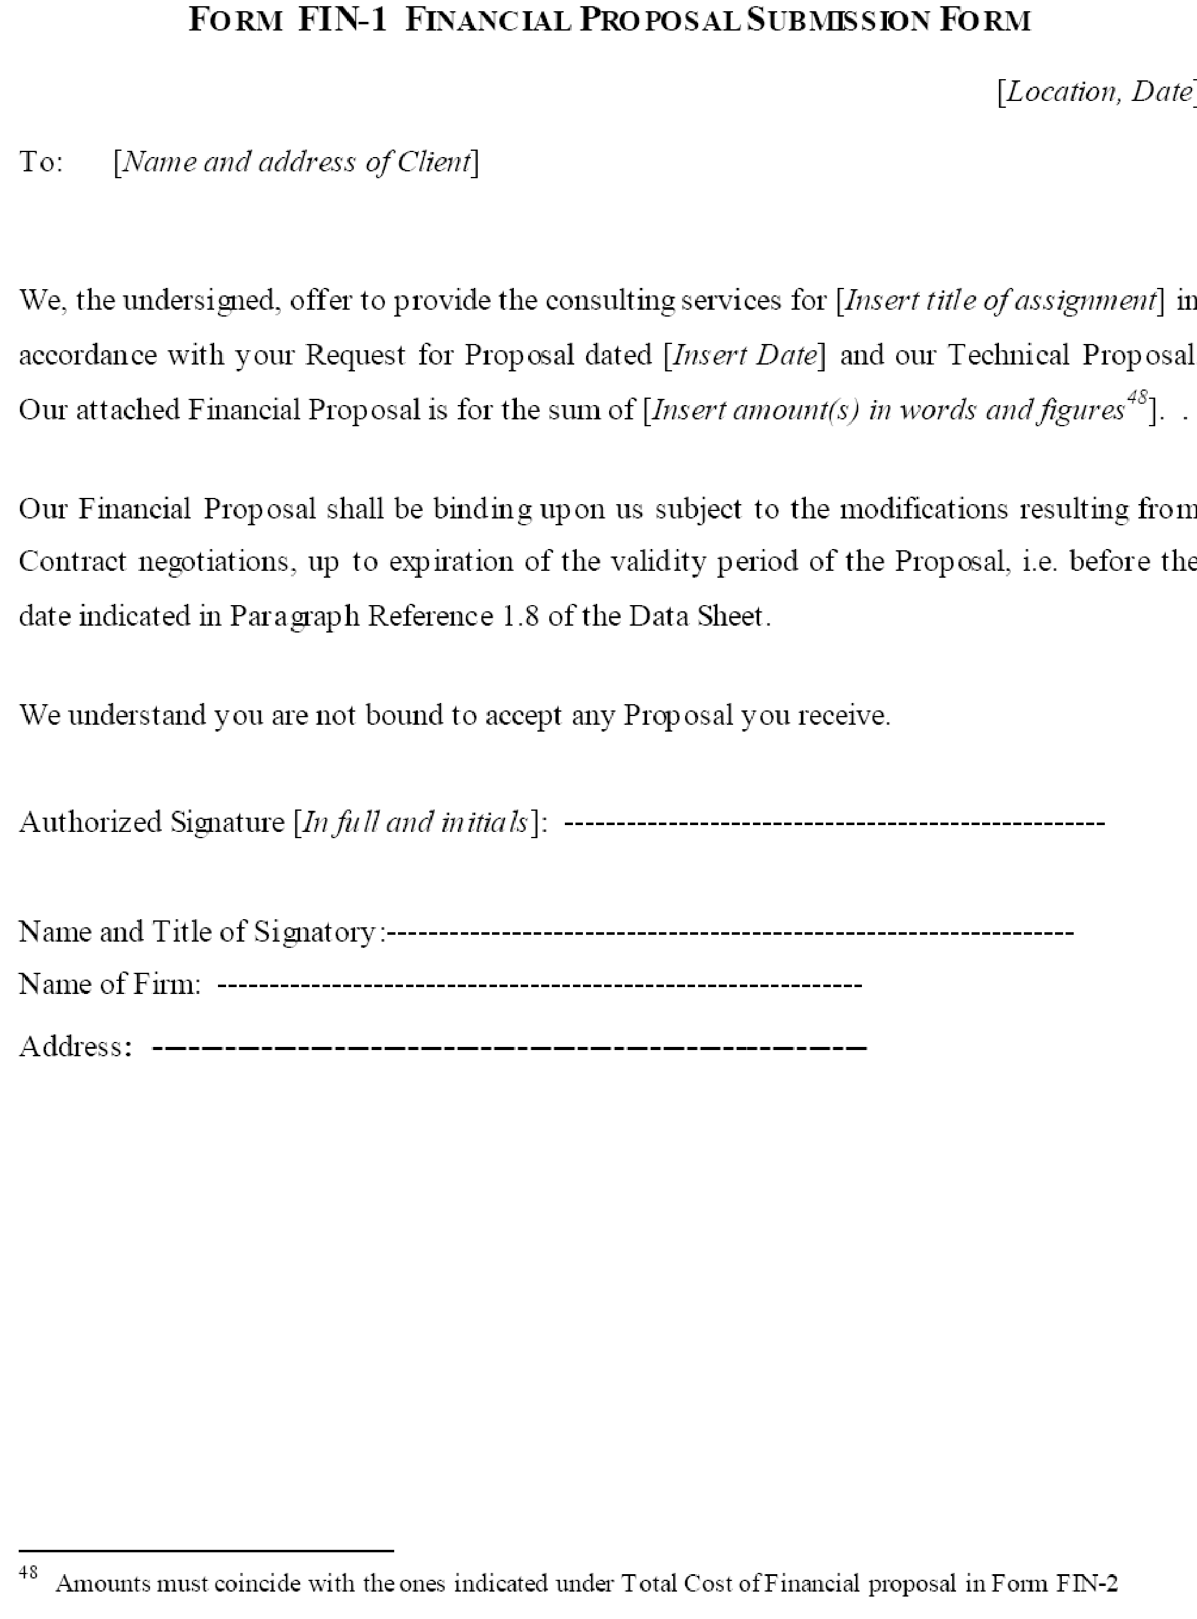

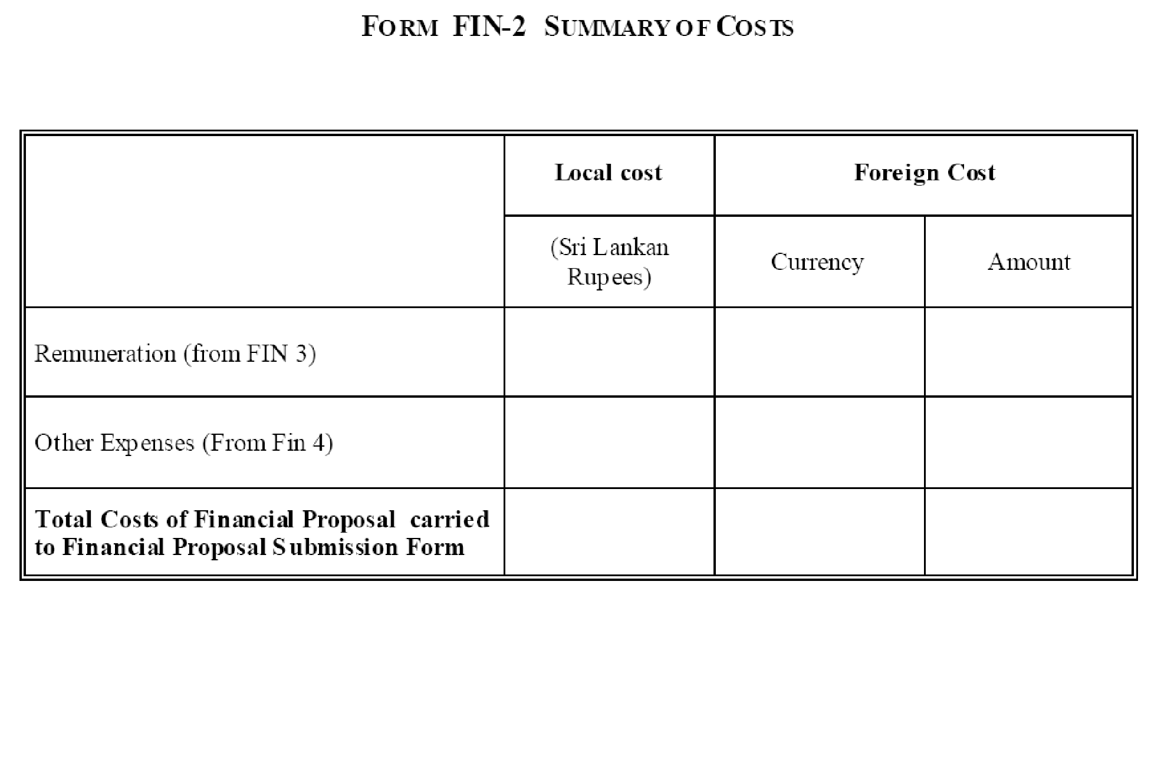

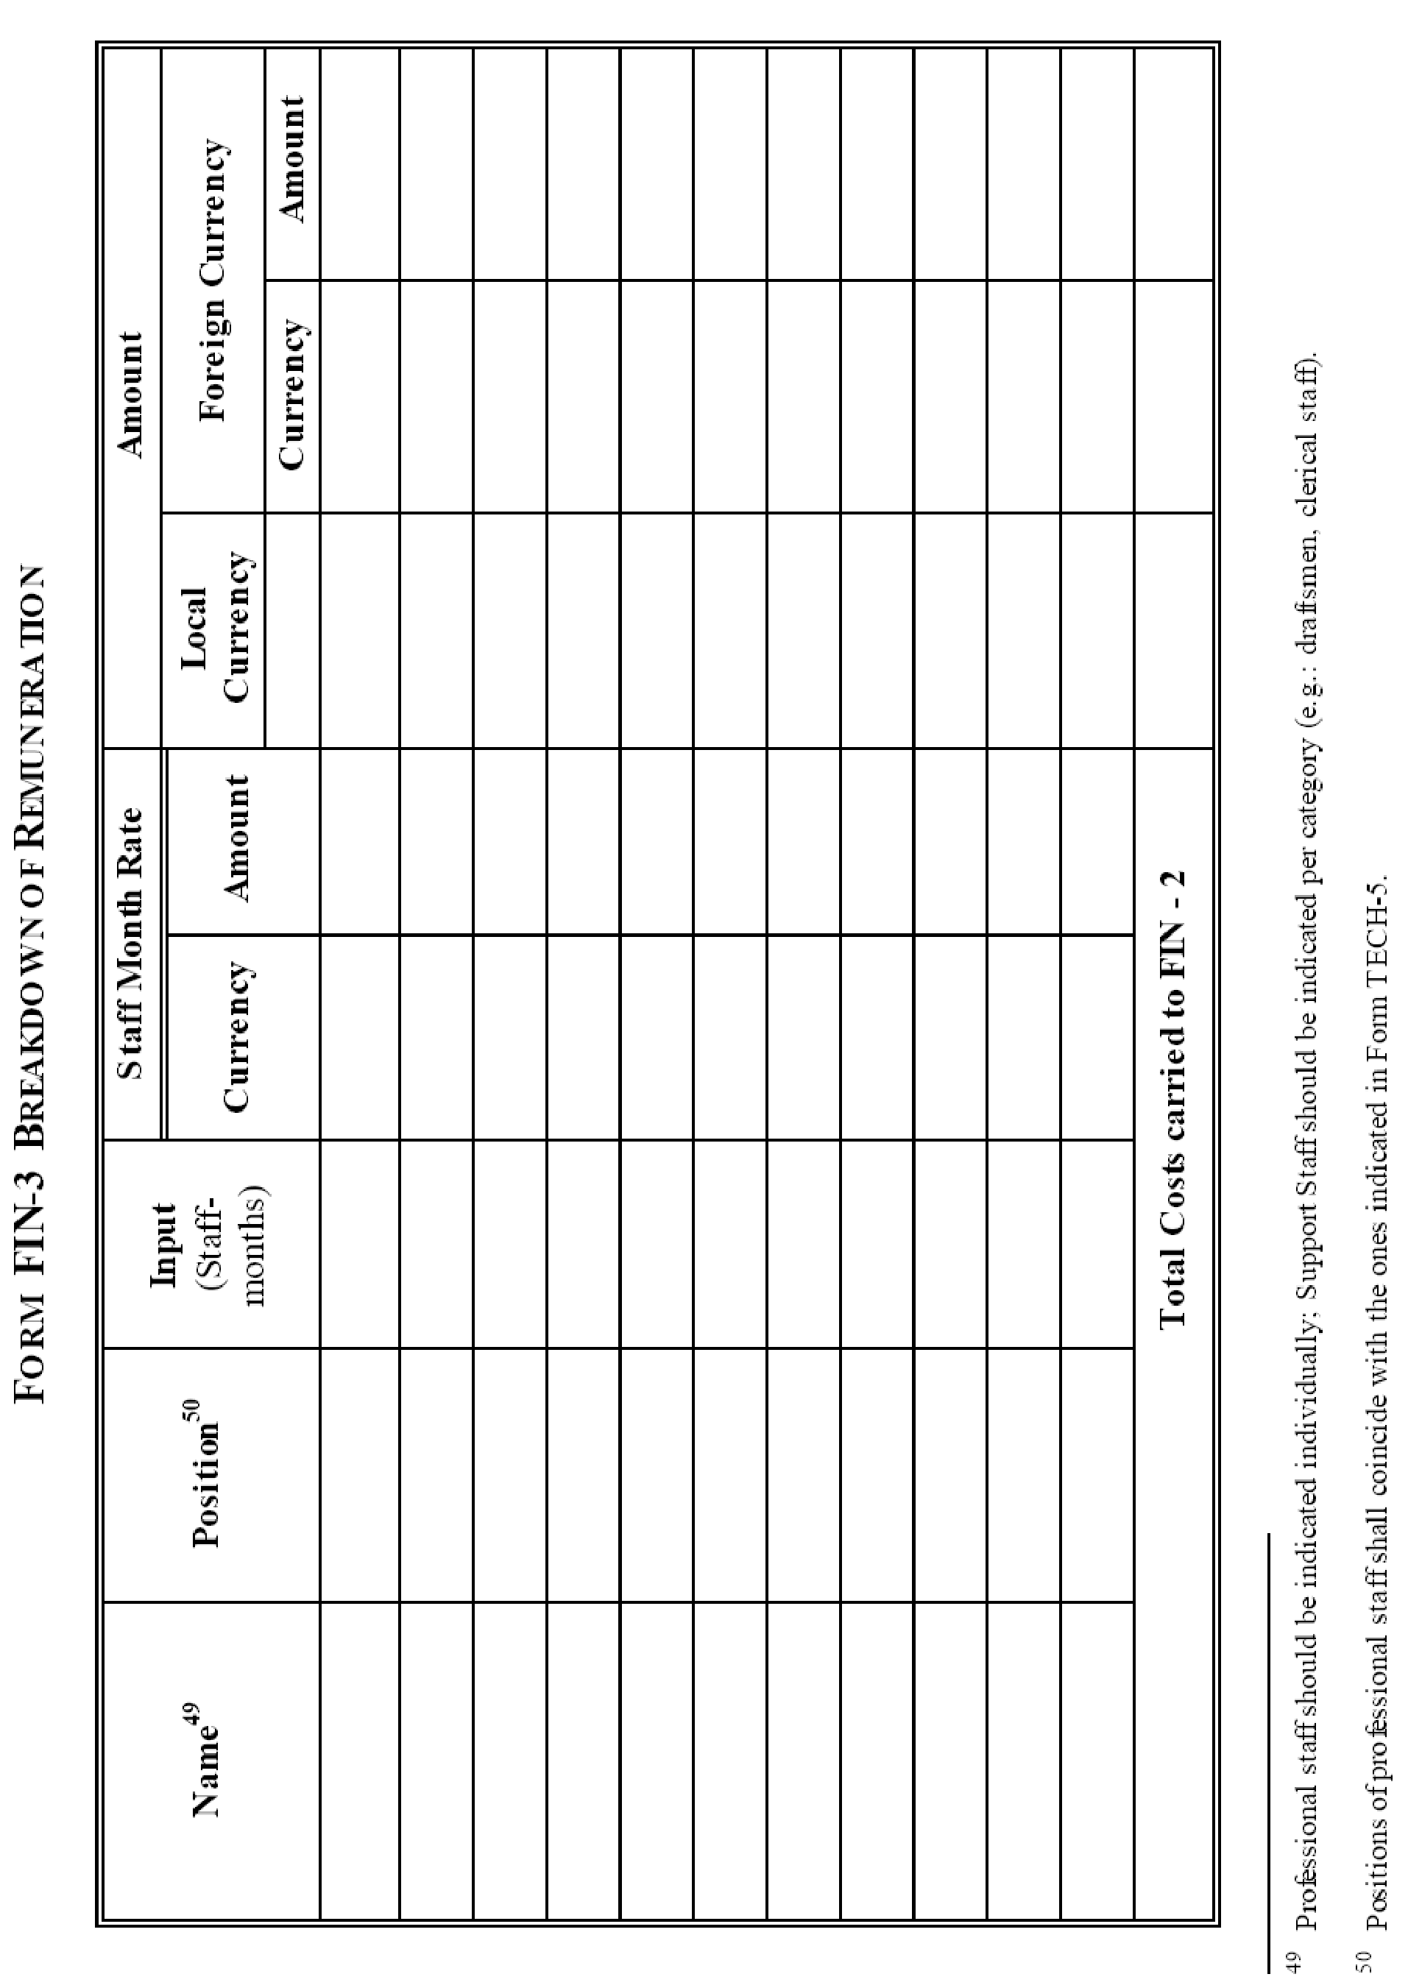

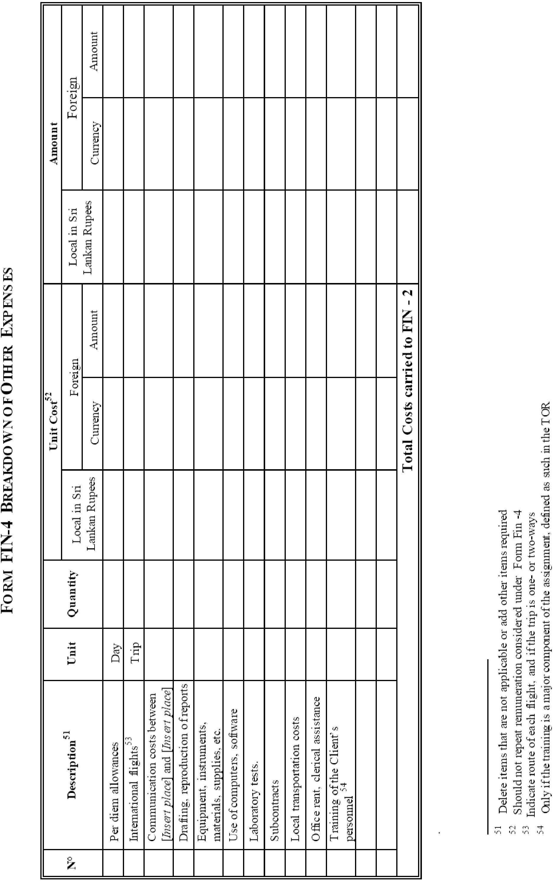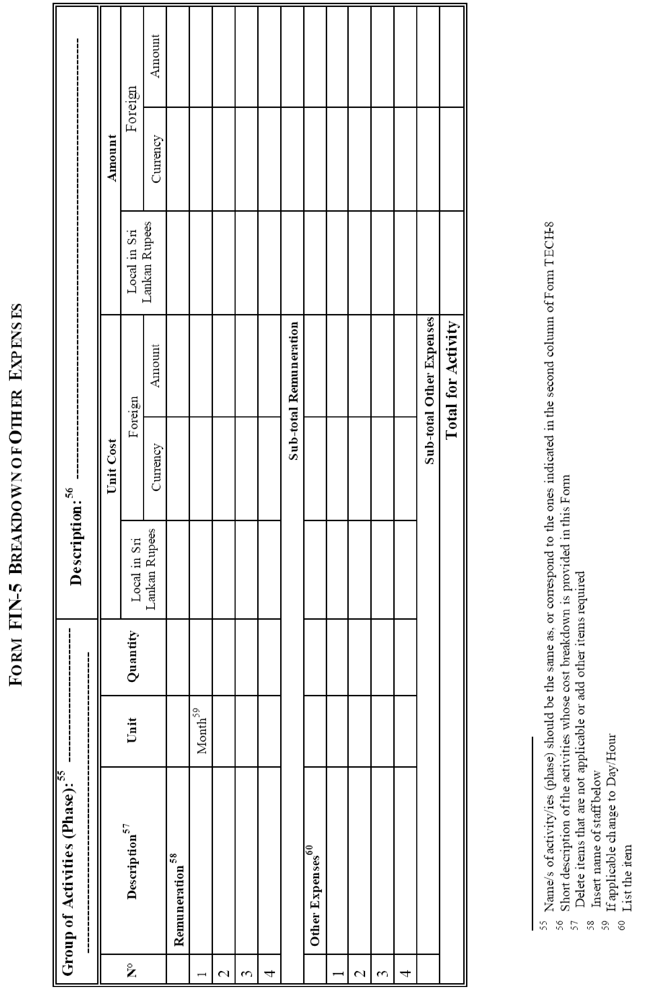

Section 5 - Terms of Reference

Terms of Reference

(a) Background

    - CPC was assigned to lay the R-LNG (Regasified Liquefied Natural Gas) pipeline from the FSRU [i.e. the Pipe Line End Manifold (PLEM)] to the existing and future power plants in Kerawalapitiya and Kelanitissa, as part of the project/program “Introduction of LNG to the country”.

    - Ceylon Electricity Board (CEB) has completed a Feasibility Study & Prepared Request for Proposal (RFP) documents with the financial assistance of Asian Development Bank (ADB) for deploying a Floating Storage Regasification Unit (FSRU) and laying pipeline from FSRU to existing and future Kerawalapitiya & Kelanitissa power plants. This feasibility study was focused on the following three (03) main sections;

  - FSRU & Mooring System- FSRU on Build, Own and Operate (BOO) Basis with mooring system on Build Own, Operate and Transfer (BOOT) Basis.

  - Pipeline – On Build, Own, Operate & Transfer (BOOT) Basis.

  - LNG Procurement – International Competitive Bidding

    - This pipeline consists of a sub-sea pipeline section and underground pipeline section. Pressures inside the pipeline shall be ranging between 70 – 30 bars and also equipped with valve stations, metering stations, pressure regulators etc. Since the continuous supply of NG for the power plants will be handled only through this pipeline it’s crucial to operate the pipeline without fail in order to ensure electricity generation of existing and future Kerawalapitiya & Kelanitissa power plants.

(b) Objectives

The objective of this activity is to appoint a consultant to provide expert services mentioned in the “Scope of services of the consultant” of this document.

(c) Scope of the Services of the consultant

The role of the Project Management Consultant (PMC) consists of followings as a minimum requirement but not limited to,
- develop the overall project implementation plan

- to furnish the project cost estimate

- set up and manage the Project Management Team (PMT) of the PMC consisting of the following personnel as a minimum,
- Senior Consultant – LNG Value Chain
- Lead Design Engineer – Mechanical and Process
- Lead Engineer – Electrical and Instrument
- Lead Engineer – Geotechnical
- Land Surveyor
- Sociology specialist
- Legal Expert
- Project Health, Safety & Environment Specialist (PHSES)
- develop Basic Design and Engineering Package (BDEP) for the project and generate complete input specifications to both the Front End Engineering Design (FEED)

- conduct a Health, Safety & Environment Impact Assessment (HSEIA) complying with the Asia Development Bank (ADB) guidelines for the pipeline route and corridors and obtain the necessary approvals from relevant agencies but not limited to Central Environmental Authority (CEA), Coast Conservation Department (CCD), Marine Environmental Protection Authority (MEPA), Road Development Authority (RDA), Urban Development Authority (UDA), Department of Wildlife Conservation, Land Commissioner General’s Department, Sri Lanka Land Reclamation & Development Corporation (SLLRDC), Department of Archaeological, Local Authorities etc. and propose mitigation actions if required.

- Co-ordinate and liaise with all government agencies and regulators to identify and obtain the necessary approvals and licenses necessary for ensuring compliance with Sri Lankan and International regulations, standards, conventions and protocols on behalf of the CPC.

- carryout topographical survey, geotechnical survey and other relevant surveys along the selected offshore and onshore sections of the pipeline route.

- finalize the pipeline route and pipeline corridors after identifying the crossings encountered by the pipeline and access areas for construction equipment, plant and materials for both the subsea and onshore sections of the pipeline with due consideration for social and environmental safeguards (even with deviations to the pipeline route proposed by CPC if necessary due to possible social impacts).

- review and update the existing feasibility study carried out by CEB for the overall purpose including the deployment of a FSRU and Mooring system and provide CPC with the completed feasibility study report for the proposed pipeline.

- identification of the most appropriate and economical construction methodologies for all the proposed developments and obtain the approval of all the stakeholders.

- prepare a project budget to an accuracy of +/- 20%, taking in to consideration of all mechanical, electrical, control and instrumentation and corrosion protection requirements.

- Develop the two separate sets of Bidding Documents complying with the Asia Development Bank (ADB) Guidelines for the following;

- EPC/Turnkey basis as per the conditions stipulated either by the
International Federation of Consulting Engineers (FIDIC).

- Build Operate Transfer (BOT) basis for construction of a Regasified Liquefied Natural Gas (R-LNG) Pipeline from Floating Storage Regasification Unit (FSRU) located around 5km off the Kerawalapitiya coastal belt to existing and future Kelanitissa and Kerawalapitiya Power Plants.

- provide all necessary assistance to CPC for the pre-bid meeting in connection with the EPC contractor / or the project proponent selection and to prepare proper answers for the clarifications raised by the interested parties at the bidding stage.

- provide all necessary technical assistance to CPC at the bid evaluation stage.

(d) Competency Requirements

The Project Management Consultant (PMC) shall ensure that all Project Management Team (PMT) staff as experience and competent in their respective duties and provide the client with detailed CVs.

The following competency requirements shall apply as a minimum requirement for the key Project Management Team (PMT) members of the PMC.

- Senior Consultant – LNG Value Chain

- Professional Engineer with minimum MSc. qualification in Oil & Gas industry with specialized in LNG sector,
- Chartered Engineer or Equivalent qualification obtained from an internationally accepted professional body,
- 15 years of professional experience in Oil & Gas industry, of which minimum eight (08) Years of proven track record in LNG value chain including minimum four (04) years in LNG project developments.

(The Four (04) points shall be allocated as follows;
Chartered Engineer – 0.5 points, Msc. Qualification in Oil & Gas industry – 0.5 points, 15 years professional experience in Oil & Gas industry – 01 point, eight (08) years proven track record in LNG value chain – 01 point and four (04) years in LNG project development – 01 Point )

- Lead Design Engineer – Mechanical and Process
- Bachelor of Science of Mechanical/Chemical Engineering,
- Chartered Engineer or Equivalent qualification obtained from an internationally accepted professional body,
- 15 years of professional experience in mechanical / process designing in Oil & Gas projects, of which six (06) years in Re-gasified Liquefied Natural Gas pipeline infrastructure projects (Onshore and offshore),
AND
- Excellent knowledge on industry standards such as API, ANSI/ASME and NFPA
(The three (03) points shall be allocated as follows;
Chartered Engineer – 0.5 points, 15 years professional experience in Oil & Gas industry – 01 point, six (06) years’ experience in Re-gasified Liquefied Natural Gas pipeline infrastructure projects – 01 point and knowledge on industry standards such as API, ANSI/ASME and NFPA – 0.5 Points )

- Lead Engineer – Electrical and Instrument
- Bachelor of Science of Electrical Engineering,
- Chartered Engineer or Equivalent qualification obtained from an professional body of the respective country,
- 10 years of professional experience in electrical designing in Oil & Gas projects, of which six (06) years in LNG infrastructure development projects (Onshore and offshore),
AND
- Excellent knowledge on industry standards
(The two (02) points shall be allocated as follows;
Chartered Engineer – 0.5 points, 10 years professional experience in Oil & Gas industry – 0.5 point, six (06) years’ experience in in LNG infrastructure development projects – 01 point)

- Lead Engineer - Geotechnical
- Bachelor of Science or Bachelor in Civil Engineering,
- Chartered Engineer or Equivalent qualification obtained from a professional body of the respective country,
AND
- 10 years of professional experience in Geotechnical designing in Oil & Gas projects, of which six (06) years in LNG infrastructure development projects (Onshore and offshore)
(The two (02) points shall be allocated as follows;
Chartered Engineer – 0.5 points, 10 years professional experience in Oil & Gas industry – 0.5 point, six (06) years’ experience in in LNG infrastructure development projects – 01 point)

- Project Health, Safety & Environment Specialist (PHSES)
- Bachelor of Science in Engineering or Process Safety,
- 10 Years of Postgraduate Experience in the Oil & Gas Industry of which five (05) years of experience as an HSE Engineer in the Oil & Gas Industry,
- NEBOSH Diploma/ NEBOSH IGC/ IOSH,
- Experience in working with Natural Gas,
- Experience in conducting HSEIA studies,
- Experience in working with International Donor Agencies,
- Experience in conducting HSE Audits,
- Qualified as a lead auditor for ISO 14001:2015 and/ or ISO 45001:2018,
AND
- A Local personnel is preferred for this position
(The one point five (1.5) points shall be allocated as follows;
Bachelor of Science in Engineering or Process Safety – 0.1 points, NEBOSH Diploma/NEBOSH IGC/IOSH – 0.05 points, Qualified as a lead auditor for ISO 14001:2015 and/ or ISO 45001:2018- 0.05 points, Experience in conducting HSEIA studies/HSE audits – 0.1 points, Experience in working with Natural gas- 0.1 points, Experience in working with International Donor Agencies – 0.1 points,10 years professional experience in Oil & Gas industry – 0.5 points, five (05) years’ experience as an HSE Engineer in the Oil & Gas Industry – 0.5 points)

- Legal Expert
- Bachelor of Law,
- Attorney at Law,
- 10 years professional experience in legal consultancy
AND
- Preferably a local person
(The one (01) point shall be allocated as follows;
Bachelor of law – 0.25 points, Attorney at Law – 0.25 point, 10 years professional experience in legal consultancy – 0.25 points and local person – 0.25 points)

- Sociological Specialist
- Bachelor of Arts or Bachelor of Science degree,
- Minimum two (02) years’ experience in working in ADB funded projects,
AND
- Either 10 years’ experience with minimum four (04) years in socio-economic, applied environment and development sociology.
(The one (01) point shall be allocated as follows;
Bachelor of Arts or Bachelor of Science degree – 0.25 points, Minimum two (02) years’ experience in working with ADB – 0.50 points,, four (04) years ‘experience in socio-economic, applied environment and development sociology – 0.25 points)

- Land Surveyor
- Bachelor of science Surveying sciences,
- A licensed surveyor,
AND
- Minimum experience of five (05) years as a surveyor for projects
(The zero point five (0.5) points shall be allocated as follows;
Bachelor of science Surveying sciences – 0.10 points, A licensed Sri Lankan Land surveyor – 0.20 points, five (05) years’ experience as a surveyor for projects – 0.20 points)

(d) Training (when appropriate) : Not applicable

(e) Reports and Time Schedule

The total period of this contract shall be Two Hundred and Forty (240) days from the date of receipt of the Purchase Order to the selected consultant.

Item | Deliverables | Time Schedule (Weeks)
1 | Preliminary Study report for the pipeline route and recommendations.
2 | Topographical, Geotechnical and other related survey reports
3 | Review and update the existing feasibility study carried out by CEB for the overall purpose including the deployment of a FSRU and Mooring system and provide CPC with the completed feasibility study report for the proposed pipeline.
4 | Recommended construction methodologies for the pipeline in the proposed route approved by the Stakeholders.
5 | Conduct a Health, Safety & Environment Impact Assessment (HSEIA) complying with the Asia Development Bank (ADB) guidelines for the pipeline route and corridors and obtain the necessary approvals from relevant agencies and propose mitigation actions if required.
6 | FEED shall include the following as a minimum but not limited to,  Design basis  Process descriptions  Process design philosophies  Material Selection Diagrams (MSDs)  Piping & Instrumentation Diagrams (P&IDs)  Tie-in list  Process equipment list  Equipment process datasheets  Instrument process datasheets  Hydraulic design reports
7 | Project budget to an accuracy of +/- 20%, taking in to consideration of all mechanical, electrical, control and instrumentation and corrosion protection requirements.
8 | Two separate sets of Bidding Documents complying with the Asia Development Bank (ADB) Guidelines for the following,  - EPC/Turnkey basis  - BOT basis.

Note: Bidders should fill the table above based on their experiences, without exceeding the total period of Contract of 240 days.

(f) Data, Local Services, Personnel, and Facilities to be provided by the Client. [Refer 1.4, Data Sheet]

Data
Following Data will be provided by CPC to the appointed consultant to carry out the expected tasks:
- The sections relevant to the pipeline construction included in the Feasibility study of CEB.
- The capacities of the existing and future LNG power plants and their proposed locations.

Local Services
Entry permits required for entering restricted areas such as Kelanitissa and Kerawelapitiya power plants will be arranged through the CPC with the coordination of CEB.

Personnel
Project team consisting of Engineering, Management and Finance professionals who will be overseeing the project activities will be available, to provide necessary information and to coordinate with stake holders of the project.
Facilities
No facilities will be provided for the Consultant by CPC.

Section 6 - Standard Form of Contract

I. Form of Contract
(Text in brackets [ ] is optional; all notes should be deleted in final text)

This CONTRACT (hereinafter called the “Contract”) is made the [day] day of the month of [month], [year], between, on the one hand, [name of client] (hereinafter called the “Client”) and, on the other hand, [name of Consultant] (hereinafter called the “Consultant”).

[Note: If the Consultant consist of more than one entity, the above should be partially amended to read as follows: “…(hereinafter called the “Client”) and, on the other hand, a joint venture/consortium/association consisting of the following entities, each of which will be jointly and severally liable to the Client for all the Consultant’s obligations under this Contract, namely, [name of Consultant] and [name of Consultant] (hereinafter called the
“Consultant”).]

WHEREAS
- the Client has requested the Consultant to provide certain consulting services as defined in this Contract (hereinafter called the “Services”);
- the Consultant, having represented to the Client that it has the required professional skills, and personnel and technical resources, has agreed to provide the Services on the terms and conditions set forth in this Contract;

NOW THEREFORE the parties hereto hereby agree as follows:
- The following documents attached hereto shall be deemed to form an integral part of this Contract:
  - The General Conditions of Contract;
  - The Special Conditions of Contract;
  - The following Appendices: [Note: If any of these Appendices are not used, the words “Not Used” should be inserted below next to the title of the Appendix]
Appendix A: Description of Services | Not used
Appendix B: Reporting Requirements | Not used
Appendix C: Personnel and Sub-Consultants | Not used
Appendix D: Breakdown of Contract Price | Not used
Appendix E: Services and Facilities provided by the Client | Not used
Appendix G: Form of Advance Payment Guarantee Not used
- The mutual rights and obligations of the Client and the Consultant shall be as set forth in the Contract, in particular:
    - the Consultants shall carry out the Services in accordance with the provisions of the Contract; and
    - the Client shall make payments to the Consultants in accordance with the provisions of the Contract.

IN WITNESS WHEREOF, the Parties hereto have caused this Contract to be signed in their respective names as of the day and year first above written.

For and on behalf of [name of Client]
…………………………………………………………
[Authorized Representative]

For and on behalf of [name of Consultant]
…………………………………………………………
[Authorized Representative]

[Note: If the Consultant consists of more than one entity, all these entities should appear as signatories, e.g., in the following manner:]

For and on behalf of each of the Members of the Consultant
[name of member]
…………………………………………………………
[Authorized Representative]

[name of member]
…………………………………………………………
[Authorized Representative]

II. General Conditions of Contract

General Conditions of Contract

1. GENERAL PROVISIONS

1.1 Definitions Unless the context otherwise requires, the following terms whenever used in this Contract have the following meanings:
- “Applicable Law” means the laws and any other instruments having the force of law in Democratic Socialist Republic of Sri Lanka, as they may be issued and in force from time to time.
- “Consultant” means any private or public entity that will provide the Services to the Client under the Contract.
- “Contract” means the Contract signed by the Parties and all the attached documents listed in its Clause 1 of the form of contract, that is these General Conditions (GC), the Special Conditions (SC), and the Appendices.
- “Contract Price” means the price to be paid for the performance of the Services, in accordance with Clause 6;
- “Day” means calendar day.
- “Effective Date” means the date on which this Contract comes into force and effect pursuant to Clause GC 2.1.
- “Foreign Currency” means any currency other than Sri Lankan Rupees.
- “GC” means these General Conditions of Contract. (i) “Member” means any of the entities that make up the joint venture/consortium/association, and “Members” means all these entities.
- “Party” means the Client or the Consultant, as the case may be, and “Parties” means both of them.
- “Personnel” means persons hired by the Consultant or by any Sub-Consultants and assigned to the performance of the Services or any part thereof. “Foreign Personnel” means such professionals and support staff that at the time of being so provided had their domicile outside Sri Lanka; “National Staff” means such professionals and support staff who at the time of being so provided had their domicile inside Sri Lanka; and “Key Personnel” means the Personnel referred to in Clause GC 4.2
- “Reimbursable expenses” means all assignment-related costs that will be paid to the Consultant on actual.
- “SC” means the Special Conditions of Contract by which the GC may be amended or supplemented.
- “Services” means the work to be performed by the Consultant pursuant to this Contract, as described in Appendix A hereto.
- “Sub-Consultants” means any person or entity to whom/which the Consultant subcontracts any part of the Services.
- “Third Party” means any person or entity other than the Government, the Client, the Consultant or a Sub-Consultant.
- “In writing” means communicated in written form with proof of receipt.
  - Relationship between the Parties Nothing contained herein shall be construed as establishing a relationship of master and servant or of principal and agent as between the Client and the Consultant. The Consultant, subject to this Contract, has complete charge of Personnel and Sub-Consultants, if any, performing the Services and shall be fully responsible for the Services performed by them or on their behalf hereunder.

  - Law Governing Contract This Contract, its meaning and interpretation, and the relation between the Parties shall be governed by the Applicable Law.
  - Language This Contract has been executed in English Language, which shall be the binding and controlling language for all matters relating to the meaning or interpretation of this Contract.
  - Headings The headings shall not limit, alter or affect the meaning of this Contract.

1.6 Notices
1.6.1 Any notice, request or consent required or permitted to be given or made pursuant to this Contract shall be in writing. Any such notice, request or consent shall be deemed to have been given or made when delivered in person to an authorized representative of the Party to whom the communication is addressed, or when sent to such Party at the address specified in the SC.
1.6.2 A Party may change its address for notice hereunder by giving the other Party notice in writing of such change to the address specified in the SC.

1.7 Location The Services shall be performed at such locations as are specified in Appendix A hereto and, where the location of a particular task is not so specified, at such locations, as the Client may approve.
1.8 Authority of the Member in Charge In case the Consultant consists of a joint venture/ consortium/ association of more than one entity, the Members hereby authorize the entity specified in the SC to act on their behalf in exercising all Consultant’s rights and obligations towards the Client under this Contract, including without limitation the receiving of instructions and payments from the Client.
1.9 Authorized Representatives Any action required or permitted to be taken, and any document required or permitted to be executed under this Contract by the Client or the Consultant may be taken or executed by the officials specified in the SC.

1.10 Taxes and Duties The Consultant, Sub-Consultants, and their Personnel shall pay such indirect taxes, duties, fees, and other impositions levied under the Applicable Law, the amount of which is deemed to have been included in the Contract Price

2. COMMENCEMENT, COMPLETION, MODIFICATION AND TERMINATION OF CONTRACT

2.1 Effectiveness of Contract This Contract shall come into force and effect on the date (the “Effective Date”) of the Client’s notice to the Consultant instructing the Consultant to begin carrying out the Services. This notice shall confirm that the effectiveness conditions, if any, listed in the SC have been met.
2.2 Commencement of Services The Consultant shall begin carrying out the Services not later than the number of Days after the Effective Date specified in the SC.

2.3 Expiration of Contract Unless terminated earlier pursuant to Clause GC 2.7 hereof, this Contract shall expire at the end of such time period after the Effective Date as specified in the SC.
2.4 Modifications or Variations Any modification or variation of the terms and conditions of this Contract, including any modification or variation of the scope of the Services, may only be made by written agreement between the Parties. However, each Party shall give due consideration to any proposals for modification or variation made by the other Party.

2.5 Force Majeure

2.5.1 Definition

- For the purposes of this Contract, “Force Majeure” means an event which is beyond the reasonable control of a Party, is not foreseeable, is unavoidable, and which makes a Party’s performance of its obligations hereunder impossible or so impractical as reasonably to be considered impossible in the circumstances, and includes, but is not limited to, war, riots, civil disorder, earthquake, fire, explosion, storm, flood or other adverse weather conditions, strikes, lockouts or other industrial action (except where such strikes, lockouts or other industrial action are within the power of the Party invoking Force Majeure to prevent), confiscation or any other action by Government agencies.

- Force Majeure shall not include (i) any event which is caused by the negligence or intentional action of a Party or such Party’s Sub-Consultants or agents or employees, nor (ii) any event which a diligent Party could reasonably have been expected both to take into account at the time of the conclusion of this Contract, and avoid or overcome in the carrying out of its obligations hereunder.
- Force Majeure shall not include insufficiency of funds or failure to make any payment required hereunder.

2.5.2 | No Breach  of Contract | The failure of a Party to fulfill any of its obligations under the contract shall not be considered to be a breach of, or default under, this Contract insofar as such inability arises from an event of Force Majeure, provided that the Party affected by such an event (a) has taken all reasonable precautions, due care and reasonable alternative measures in order to carry out the terms and conditions of this Contract, and (b) has informed the other Party as soon as possible about the occurrence of such an event.
2.5.3 | Measures to be  Taken | (a) A Party affected by an event of Force Majeure shall continue to perform its obligations under the Contract as far as is reasonably practical, and shall take all reasonable measures to minimize the consequences of any event of Force Majeure.
- A Party affected by an event of Force Majeure shall notify the other Party of such event as soon as possible, and in any case not later than fourteen (14) Days following the occurrence of such event, providing evidence of the nature and cause of such event, and shall similarly give written notice of the restoration of normal conditions as soon as possible.
- Any period within which a Party shall, pursuant to this Contract, complete any action or task, shall be extended for a period equal to the time during which such Party was unable to perform such action as a result of Force Majeure.
- During the period of their inability to perform the Services as a result of an event of Force Majeure, the Consultant, upon instructions by the Client, shall either:
  - demobilize, in which case the Consultant shall be reimbursed for additional costs they reasonably and necessarily incurred, and, if required by the Client, in reactivating the Services; or
  - Continue with the Services to the extent possible, in which case the Consultant shall continue to be paid under the terms of this Contract and be reimbursed for additional costs reasonably and necessarily incurred.
In the case of disagreement between the Parties as to the existence or extent of Force Majeure, the matter shall be settled according to Clause GC 8.

2.6 | Suspension | The Client may by written notice of suspension to the Consultant, suspend all payments to the Consultant hereunder if the Consultant fails to perform any of its obligations under this Contract, including the carrying out of the Services, provided that such notice of suspension (i) shall specify the nature of the failure, and (ii) shall request the Consultant to remedy such failure within a period not exceeding thirty (30) Days after receipt by the Consultant of such notice of suspension.
2.7 | Termination
2.7.1 | By the  Client | The Client may terminate this Contract in case of the occurrence of any of the events specified in paragraphs (a) through (f) of this Clause GC 2.7.1. In such an occurrence the Client shall give a not less than thirty (30) Days’ written notice of termination to the Consultant, and sixty (60) Days in the case of the event referred to in (e).
- If the Consultant fails to remedy a failure in the performance of its obligations hereunder, as specified in a notice of suspension pursuant to Clause GC 2.6 hereinabove, within thirty (30) Days of receipt of such notice of suspension or within such further period as the Client may have subsequently approved in writing.
- If the Consultant becomes (or, if the Consultant consists of more than one entity, if any of its Members becomes) insolvent or bankrupt or enter into any agreements with their creditors for relief of debt or take advantage of any law for the benefit of debtors or go into liquidation or receivership whether compulsory or voluntary.
- If the Consultant fails to comply with any final decision reached as a result of arbitration proceedings pursuant to Clause GC 8 hereof.
- If the Consultant, in the judgment of the Client has engaged in corrupt or fraudulent practices in competing for or in executing the Contract.
- If as the result of Force Majeure, the Consultant is unable to perform a material portion of the Services for a period of not less than sixty (60) Days.
- If the Client in its sole discretion and for any reason
whatsoever decides to terminate this Contract.
2.7.2 By the The Consultants may terminate this Contract by not less than
Consultant thirty (30) Days written notice to the Client, such notice to be given after the occurrence of any of the events specified in paragraphs (a) through (c) of this Clause GC 2.7.2:
- If the Client fails to pay any money due to the Consultant pursuant to this Contract and not subject to dispute pursuant to Clause GC 8 hereof within sixty (60) days after receiving written notice from the Consultant that such payment is overdue.
- If, as the result of Force Majeure, the Consultant is unable to perform a material portion of the Services for a period of not less than ninety (90) Days.
- If the Client fails to comply with any final decision reached as a result of arbitration pursuant to Clause GC 8 hereof.
2.7.3 Cessation of Upon termination of this Contract pursuant to Clauses GC Rights and 2.7 hereof, or upon expiration of this Contract pursuant to Obligations Clause GC 2.3 hereof, all rights and obligations of the
Parties hereunder shall cease, except (i) such rights and obligations as may have accrued on the date of termination or expiration, (ii) the obligation of confidentiality set forth in Clause GC 3.3 hereof, ( iii) the Consultant’s obligation to permit inspection, copying and auditing of their accounts and records set forth in Clause GC 3.6 hereof, and (iv) any right which a Party may have under the Applicable Law.
2.7.4 Cessation of Upon termination of this Contract by notice of either Party Services to the other pursuant to Clauses GC 2.7.1 or GC 2.7.2
hereof, the Consultant shall immediately upon dispatch or receipt of such notice take all necessary steps to bring the Services to a close in a prompt and orderly manner and shall make every reasonable effort to keep expenditures for this purpose to a minimum. With respect to documents prepared by the Consultant and equipment and materials furnished by the Client, the Consultant shall proceed as provided, respectively by Clauses GC 3.7 hereof.

2.7.5 Payment Upon termination of this Contract pursuant to Clauses GC upon 2.7.1 or GC 2.7.2, the Client shall make the following Termination payments to the Consultant:
- payment and reimbursable expenditure pursuant to Clause
GC 6 for Services satisfactorily performed prior to the effective date of termination;
- except in the case of termination pursuant to paragraphs (e) and (f) of Clause GC 2.7.1, reimbursement of any reasonable cost incident to the prompt and orderly termination of the Contract,
- including the cost of the return travel of the Personnel and their eligible dependents.

2.7.6 | Disputes  about Events of  Termination | If either Party disputes whether an event specified in Clause GC 2.9.1 or in Clause GC 2.9.2 hereof has occurred, such Party may, within forty-five (45) days after receipt of notice of termination from the other Party refer the matter to Clause GC 8 hereof and this Contract shall not be terminated on account of such event, except in accordance with the terms of any resulting arbitral award.

3. OBLIGATIONS OF THE CONSULTANT

3.1 General

3.1.1 Standard of Performance
The Consultant shall perform the Services and carry out their obligations hereunder with all due diligence, efficiency and economy, in accordance with generally accepted professional standards and practices, and shall observe sound management practices and employ appropriate technology and safe and effective equipment, machinery, materials and methods. The Consultant shall always act, in respect of any matter relating to this Contract or to the Services as faithful advisers to the Client, and shall at all times support and safeguard the Client’s legitimate interests in any dealings with Sub-Consultants or third Parties.

3.2 Conflict of Interests
The Consultant shall hold the Client’s interests paramount without any consideration for future re-work and strictly avoid conflict with other assignments or their own corporate interests.
3.2.1 Consultants Not to Benefit from Commissions, Discounts etc.

The payment of the Consultant pursuant to Clause GC 6 shall constitute the Consultant’s only payment in connection with this Contract or the Services, and the Consultant shall not accept for, their own benefit any trade commission, discount, or similar payment in connection with activities pursuant to this Contract or. to the Services or in the discharge of their obligations under the Contract, and the Consultant shall use their best efforts to ensure that the Personnel, any Sub-Consultants, and agents of either of them similarly shall not receive any such additional payment.
3.2.2 Consultant and Affiliates Not to be Otherwise Interested in Project

The Consultant agrees that during the term of this Contract and after its termination, the Consultant and any entity affiliated with the Consultant, as well as any Sub-Consultants and any entity affiliated with such Sub-Consultants, shall be disqualified from providing goods, works or services (other than consulting services) resulting from or directly related to the Consultant’s Services for the preparation or implementation of the project.
3.2.3 Prohibition of Conflicting Activities

The Consultant shall not engage and shall cause their Personnel as well as their Sub-Consultants and their Personnel not to engage either directly or indirectly in any business or professional activities, which would conflict with the activities assigned to them under this Contract.

3.3 Confidentiality
Except with the prior written consent of the Client, the Consultant and the Personnel shall not at any time communicate to any person or entity any confidential information acquired in the course of the Services, nor shall the Consultant and the Personnel make public the recommendations formulated in the course of, or as a result of the Services.

3.4 Insurance to be Taken Out by the Consultant

The Consultant
(a) shall take out and maintain, and shall cause any Sub-Consultants to take out and maintain, at their (or the Sub- Consultants’, as the case may be) own cost but on terms and conditions approved by the Client, insurance against the risks, and for the coverage, as shall be specified in the SC; and
(b) at the Client’s request, shall provide evidence to the Client showing that such insurance has been taken out and maintained and that the current premiums have been paid.

3.5 Consultant’s Actions Requiring Client’s Prior Approval

The Consultant shall obtain the Client’s prior approval in writing before taking any of the following actions:
- entering into a subcontract for the performance of any part of the Services,
- appointing such members of the Personnel not listed by name in Appendix C, and
- any other action that may be specified in the SC.

3.6 Reporting Obligations

- The Consultant shall submit to the Client the reports and documents specified in Appendix B hereto in the form in the numbers and within the time periods set forth in the said Appendix.

(b) Final reports shall be delivered in CD ROM in addition to the hard copies specified in said Appendix.

3.7 Documents Prepared by the Consultant to be the Property of the Client
(a) All plans, drawings, specifications, designs, reports, other documents and software submitted by the Consultant under this Contract shall become and remain the property of the Client, and the Consultant shall not later than upon termination or expiration of this Contract, deliver all such documents to the Client together with a detailed inventory thereof.
(b) The Consultant may retain a copy of such documents and software. Restrictions about the future use of these documents, if any shall be specified in the SC.
3.8 Accounting, Inspection and Auditing
The Consultant (i) shall keep accurate and systematic accounts and records in respect of the Services hereunder in accordance with accepted accounting principles and in such form and detail as will clearly identify all relevant time changes and costs and the bases thereof, and (ii) shall periodically permit the Client or its designated representative and/or the Bank, and up to two years from the expiration or termination of this Contract to inspect the same and make copies thereof as well as to have them audited by auditors appointed by the Client or the Bank, if so required by the Client or the Bank as the case may be.

- C_{ONSULTANT’S} PERSONNEL

4.1 | Description of  Personnel | (a) | The Consultant shall employ and provide such qualified and experienced Personnel and Sub-Consultants as are required to carry out the Services. The titles, agreed job descriptions, minimum qualifications, and estimated periods of engagement in the carrying out of the Services of the Consultant’s Key Personnel are described in Appendix C. The Key Personnel and Sub- Consultants listed by title as well as by name in Appendix C are hereby approved by the Client.
 |  | (b) | If required to comply with the provisions of Clause GC 3.1.1 hereof, adjustments with respect to the estimated periods of engagement of Key Personnel set forth in Appendix C may be made by the Consultant by written notice to the Client, provided (i) that such adjustments shall not alter the originally estimated period of engagement of any individual by more than 10% or one week whichever is larger, and (ii) that the aggregate of such adjustments shall not cause payments under this Contract to exceed the ceilings set forth in Clause GC 6.1(b) of this Contract. Any other such adjustments shall only be made with the Client’s written approval.
 |  | (c) | If additional work is required beyond the scope of the Services specified in Appendix A, the estimated periods of engagement of Key Personnel set forth in Appendix C may be increased by agreement in writing between the Client and the Consultant. In case where payments under this Contract exceed the ceilings set forth in Clause GC 6.2 of this Contract, this will be explicitly mentioned in the agreement.
4.2 | Approval of  Personnel | The Key Personnel and Sub-Consultants listed by title as well as by name in Appendix C are hereby approved by the Client. In respect of other Personnel which the Consultant proposes to use in the carrying out of the Services, the Consultant shall submit to the Client for review and approval a copy of their Curriculum Vitae (CVs’). If the Client does not object in writing (stating the reasons for the objection) within twenty-one (21) Days from the date of
receipt of such CVs, such Personnel shall be deemed to have been approved by the Client.
  - Working Hours, Overtime, Leave, etc

In case where Consultant will be paid based on the time spend by, any Personnel the Working hours and holidays for such Personnel, are set forth in Appendix C hereto. To account for travel time, Foreign Personnel carrying out Services inside Sri Lanka shall be deemed to have commenced, or finished work in respect of the Services such number of days before their arrival in or after their departure from Sri Lanka as is specified in Appendix C hereto. Such Key Personnel shall not be entitled to be paid for overtime nor to take paid sick leave or vacation leave except as specified in Appendix C hereto, and except as specified in such Appendix, the Consultant’s remuneration shall be deemed to cover these items. All leave to be allowed to the Personnel is included in the staff months of service set forth in Appendix C. Any taking of leave by Personnel shall be subject to the prior approval by the Consultant who shall ensure that absence for leave purposes will not delay the progress and adequate supervision of the Services.

  - Removal and/or Replacement of Personnel
(a) Except as the Client may otherwise agree no changes shall be made in the Key Personnel. If for any reason beyond the reasonable control of the Consultant such as retirement, death, medical incapacity, among others it becomes necessary to replace any of the Key Personnel, the Consultant shall provide as a replacement a person of equivalent or better qualifications.
    - If the Client finds that any of the Personnel have (i) committed serious misconduct or have been charged with having committed a criminal action, or (ii) have reasonable cause to be dissatisfied with the performance of any of the Personnel, then the Consultant shall at the Client’s written request specifying the grounds thereof provide as a replacement a person with qualifications and experience acceptable to the Client. (An equally competent professional acceptable to the client should only replace any change of key personnel.)
    - The Consultant shall have no claim for additional costs arising out of or incidental to any removal and/or replacement of Personnel.

5. OBLIGATIONS OF THE CLIENT
5.1 Assistance and Exemptions
Unless otherwise specified in the SC, the Client shall use its best efforts to ensure that the Government of Sri Lanka shall:
- Provide where applicable the Consultant, Sub-Consultants and Personnel with work permits and such other documents as shall be necessary to enable the Consultant, Sub Consultants or Personnel to perform the Services.
- Arrange where applicable for the Personnel and if appropriate, their eligible dependents to be provided promptly with all necessary entry and exit visas, residence permits, exchange permits and any other documents required for their stay in Sri Lanka.
- Facilitate where applicable prompt clearance through customs of any property required for the Services and of the personal effects of the Personnel and their eligible dependents.
- Issue to officials, agents and representatives of the Government agencies all such instructions as may be necessary or appropriate for the prompt and effective implementation of the Services.
- Provide to the Consultant, Sub-Consultants and Personnel any such other assistance as may be specified in the SC.
  - Change in the Applicable Law Related to Taxes and Duties

If after the date of this Contract, there is any change in the Applicable Law with respect to taxes and duties which increases or decreases the cost incurred by the Consultant in performing the Services, then the remuneration and reimbursable expenses otherwise payable to the Consultant under this Contract shall be increased or decreased accordingly by agreement between the Parties and corresponding adjustments shall be made to the amounts referred to in Clauses GC 6.2

  - Services and Facilities

(a) The Client shall make available free of charge to the Consultant the professional and support counterpart personnel, Services and Facilities listed under Appendix E.
(b) In case that such personnel, services, facilities and property shall not be made available to the Consultant as and when specified in Appendix E, the Parties shall agree on ( i) how the affected part of the Services shall be carried out ; (ii) any time extension that it may be appropriate to grant to the Consultant for the performance of the Services, (iii) the manner in which the Consultant shall procure any such personnel, services, facilities and property from other sources, and (iv) the additional payments if any, to be made to the Consultant as a result thereof pursuant to Clause GC 6 hereinafter.

5.4 Counterpart Personnel

(a) The Client shall make available to the Consultant free of charge such professional and support counterpart personnel to be nominated by the Client with the Consultant’s advice if specified in Appendix E.
- If counterpart personnel are not provided by the Client to the Consultant as and when specified in Appendix E, the Client and the Consultant shall agree on (i) how the affected part of the Services shall be carried out and (ii) the additional payments if any, to be made by the Client to the Consultant as a result thereof pursuant to Clause GC 6.4 for option A or 6.3 for option B.
- Professional and support counterpart personnel excluding Client’s liaison personnel shall work under the exclusive direction of the Consultant. If any member of the counterpart personnel fails to perform adequately any work assigned to such member by the Consultant that is consistent with the position occupied by such member, the Consultant may request the replacement of such member and the Client shall not unreasonably refuse to act upon such request.

6. PAYMENTS TO THE CONSULTANT

6.1 Option ‘A’ or Option A is applicable. Option ‘B’

OPTION A (Clause 6.2 to 6.6 below are applicable)
6.2 Lump-Sum Payment

The total payment due to the Consultant shall not exceed the Contract Price which is an all inclusive fixed lump-sum covering all costs required to carry out the Services described in Appendix A. Except as provided in Clause 5.2, the Contract Price may only be increased above the amounts stated in Clause 6.3 if the Parties have agreed to additional payments in accordance with Clause 2.4 or clause 5.4.
6.3 Contract Price
(a) The price payable in Sri Lankan Rupees is set forth in the Special Conditions of Contract (SC).
(b) The price payable in foreign currency/currencies is set forth in the SC.

6.4 Payment for Additional Services

For the purpose of determining the remuneration due for additional services as may be agreed under Clause 2.4, a breakdown of the lump sum price is provided in Appendices D.

6.5 Terms and Conditions of Payment

Payments will be made according to the payment schedule stated in the SC. Unless otherwise stated in the SC, the first payment shall be made against the provision by the Consultant of an advance payment guarantee acceptable to the Client in an amount (or amounts) and in a currency (or currencies) specified in the SC. Such guarantee (i) to remain effective until the advance payment has been fully set off, and (ii) to be in the form set forth in Appendix D hereto or in such other form as the Client shall have approved in writing. The advance payments will be set off by the Client in installments proportionate to the payments made to the Consultant. Any other payment shall be made after the conditions listed in the SC for such payment have been met and the Consultant has submitted an invoice to the Client specifying the amount due.

6.6 | Interest on  Delayed  Payments | If the Client has delayed payments beyond fourth five (45) days after the due date stated in the Clause SC 6.5, interest shall be paid to the Consultant for each day of delay at the rate stated in the SC.
 |  | 7. GOOD FAITH
7.1 | Good Faith | The Parties undertake to act in good faith with respect to each other’s rights under this Contract and to adopt all reasonable measures to ensure the realization of the objectives of this Contract.

8. SETTLEMENT OF DISPUTES

8.1 | Amicable  Settlement | - The Parties agree that the avoidance or early resolution of disputes is crucial for a smooth execution of the Contract and the success of the assignment. The Parties shall use their best efforts to settle amicably all disputes arising out of or in connection with this Contract or its interpretation.  - If either Party objects to any action or inaction of the other  Party, the objecting Party may file a written Notice of Dispute to the other Party providing in detail the basis of the dispute. The Party receiving the Notice of Dispute will consider it and respond in writing within 30 Days after receipt. If that Party fails to respond within 30 Days, or the dispute cannot be amicably settled within 30 Days following the response of that Party, Clause GC 8.2 shall apply.
8.2 | Dispute  Resolution | Any dispute between the Parties as to matters arising pursuant to this Contract that cannot be settled amicably within thirty (30) Days after receipt by one Party of the other Party’s request for such amicable settlement may be submitted by either Party for settlement in accordance with the provisions specified in the SC and in accordance with Sri Lanka Arbitration Act No. 11 of 1995.

III. Special Conditions of contract

Number of GC Clause | Amendments of, and Supplements to, Clauses in the General Conditions of Contract
1.6 | The addresses are:  Client: Ceylon Petroleum Corporation  Attention:  Facsimile:  E-mail:  Consultant:  Attention:  Facsimile:  E-mail:
{1.8} | {The Member in Charge is [insert name of member]}  Note: If the Consultant consists of a joint venture/ consortium/ association of more than one entity, the name of the entity whose address is specified in Clause SC 1.8 should be inserted here. Maximum number of partners in the Joint Venture shall be limited to 03 (Three). One of the members of the Joint Venture firm shall be its lead member who shall have majority (at least 51%) share of interest in the JV firm. The other member/s shall have a share of not less than 10% each in case of JV firms. If the Consultant consists only of one entity, this Clause SC 1.8 should be deleted from the SC.
1.9 | The Authorized Representatives are:  For the Client:  For the Consultant:
{2.1} | {The Effectiveness conditions are:}
2.2 | The date for the commencement of Services is [insert days].Days from the effective date.
2.3 | The time period shall be [insert time period, e.g.: 240 Days].
3.4 | The risks and the coverage shall be as follows:  - Third Party motor vehicle liability insurance in respect of motor vehicles operated by the Consultant or its Personnel or any Sub-Consultants or their Personnel;  - Third Party liability insurance, with a minimum coverage of [insert amount];  - Professional liability insurance, with a minimum coverage of 110% of the consultancy service;

{3.5(c) } | {The other actions are: [insert actions].}  Note: If there are no other actions, delete this Clause SC 3.5 (c).
{3.7(b) } | Note: If there is to be no restriction on the future use of these documents by either Party, this Clause SC 3.7 should be deleted. If the Parties wish to restrict such use, any of the following options, or any other option agreed to by the Parties, may be used:  {The Consultant shall not use these documents and software for purposes unrelated to this Contract without the prior written approval of the Client.} {The Client shall not use these documents and software for purposes unrelated  to this Contract without the prior written approval of the Consultant.} {Neither Party shall use these documents and software for purposes unrelated to this Contract without the prior written approval of the other Party.}
5.1} | Note: List here any assistance or exemptions that the Client may provide under Clause 5.1. If there is no such assistance or exemptions, state “not applicable.”
6.1 | The applicable option is : Option A
Option A
6.3(a) | The amount in Sri Lankan Rupees is [insert amount].
6.3(b) | The amount in foreign currency or currencies is [insert amount].
6.5 | Payments shall be made according to the following schedule:  Note: (a) the following installments are indicative only; and (b) if applicable, detail further the nature of the report evidencing performance, as may be required, e.g., submission of study or specific phase of study, survey, drawings, draft bidding documents, etc., as listed in Appendix B, Reporting Requirements.  Local Currency Component:  - An advance payment not exceeding Twenty (20) percent of the Local Currency component shall be paid on the date of effectiveness, against the submission of an on-demand Bank guarantee for the same amount. This advance payment will be recovered by deducting at the rate of 25% from each interim payments  - Fifteen (15) percent of the lump-sum amount of the Sri Lankan Rupee component shall be paid upon fulfillment of the below milestones:  - Submission of Preliminary Study report for the pipeline route with recommendations.  - Submission of Topographical survey reports  - Submission of Geotechnical survey reports.  - Submission of updated and completed feasibility study for the proposed pipeline for the existing feasibility study carried out by CEB for the overall purpose including the deployment of a FSRU and Mooring system  - Twenty Five (25) percent of the lump-sum amount of the Sri Lankan Rupee component shall be paid upon Submission of Recommended construction methodologies for the pipeline in the proposed route and obtaining of the approval from Road Development Authority and/or Provincial Road Development Authority.  - Twenty (20) percent of the lump-sum amount of the Sri Lankan Rupee component shall be paid upon submission of EIA report as per the ADB guidelines in line with the requirement of Central Environmental Authority / Costal Conservation Department of Sri Lanka and proposals for mitigation measures if required.  - Twenty (20) percent of the lump-sum amount of the Sri Lankan Rupee component shall be paid upon submission of FEED and Project budget.  - Ten (10) percent of the lump-sum amount of the Sri Lankan Rupee component shall be paid upon submission of Bidding document for EPC/Turnkey Contract as per FIDIC conditions of contract  - Ten (10) percent of the lump-sum amount of the Sri Lankan Rupee component shall be paid upon Provide assistance during evaluation and up to award of the EPC/Turnkey contract to a suitable contractor.

Foreign Currency Component:

- An advance payment not exceeding Twenty (20) percent of the foreign currency component shall be paid on the date of effectiveness, against the submission of an on-demand Bank guarantee for the same amount. This advance payment will be recovered by deducting at the rate of 25% from each interim payments

- Fifteen (15) percent of the lump-sum amount of the foreign currency component shall be paid upon fulfillment of the below milestones:
  - Submission of Preliminary Study report for the pipeline route with recommendations.
  - Submission of Topographical survey reports
  - Submission of Geotechnical survey reports.
  - Submission of updated and completed feasibility study for the proposed pipeline for the existing feasibility study carried out by CEB for the overall purpose including the deployment of a FSRU and Mooring system

- Twenty Five (25) percent of the lump-sum amount of the foreign currency component shall be paid upon Submission of Recommended construction methodologies for the pipeline in the proposed route and obtaining of the approval from Road Development Authority.

- Twenty (20) percent of the lump-sum amount of the foreign currency component shall be paid upon submission of EIA report in line with the requirement of Central Environmental Authority / Costal Conservation Department of Sri Lanka and proposals for mitigation measures if required.

- Twenty (20) percent of the lump-sum amount of the foreign currency component shall be paid upon submission of FEED and Project budget.

- Ten (10) percent of the lump-sum amount of the foreign currency component shall be paid upon submission of Bidding document for EPC/Turnkey Contract as per FIDIC conditions of contract

- Ten (10) percent of the lump-sum amount of the foreign currency component shall be paid upon Provide assistance during evaluation and up to award of the EPC/Turnkey contract to a suitable contractor.

6.6 | The interest rate is: [insert rate].
8.2 | Disputes shall be settled by arbitration in accordance with the following provisions:  1. Selection of Arbitrators. Each dispute submitted by a Party to arbitration shall be heard by a sole arbitrator:
(a) The Parties may agree to appoint a sole arbitrator or, failing agreement on the identity of such sole arbitrator within thirty (30) Days after receipt by the other Party of the proposal of a name for such an appointment by the Party who initiated the proceedings, either Party may apply to High Court of Sri Lanka to nominate the arbitrator for the matter in dispute.

- Substitute Arbitrators. If for any reason an arbitrator is unable to perform his function, a substitute shall be appointed in the same manner as the original arbitrator.

- The decision of the sole arbitrator shall be final and binding and shall be enforceable in any court of competent jurisdiction, and the Parties hereby waive any objections to or claims of immunity in respect of such enforcement.

- The Place of Arbitration shall be in Sri Lanka

9 | Late Completion :  If the consultant fails to complete the Consultancy Services within the intended Completion period of Hundred & Eighty (180) days, Consultant’s liability to the employer for such failure shall be 0.05% of the Initial contract value per day, subject to the minimum of 10% of the Initial Contract value.

IV. Appendices

APPENDIX A – DESCRIPTION OF SERVICES
Note: This Appendix will include the final Terms of Reference worked out by the Client and the Consultants during technical negotiations. Give detailed descriptions of the Services to be provided, dates for completion of various tasks, place of performance for different tasks, specific tasks to be approved by Client, etc.

APPENDIX B - REPORTING REQUIREMENTS
Note: List format, frequency, and contents of reports; persons to receive them; dates of submission; etc. If no reports are to be submitted, state here “Not applicable.”

APPENDIX C - KEY PERSONNEL AND SUB-CONSULTANTS
Note: List under:

C-1 Titles [and names, if already available], detailed job descriptions and minimum qualifications of Key Personnel to be assigned to work, and estimated staff-months for each.

C-2 List of approved Sub-Consultants (if already available); same information with respect to their Personnel as in C-1.In case where Consultant will be paid based on the time spend by any Personnel, list here the hours of work for Key Personnel; travel time to and from the country of the Government for Foreign Personnel (Clause GC 4.4(a)); entitlement, if any, to overtime pay, sick leave pay, vacation leave pay, etc.

APPENDIX D - BREAKDOWN OF CONTRACT PRICE
Note: List here the elements of cost used to arrive at the breakdown of the lump-sum price - foreign currency portion:
- Monthly rates for Personnel (Key Personnel and other Personnel).
- Reimbursable expenses (items that are not applicable should be deleted; others may be added):
  - Per Diem allowances for each of the Personnel for every day in which such Personnel shall be required to work outside the Location

  - Air transport for Foreign Personnel: the cost of international transportation of the foreign Personnel by the most appropriate means of transport and the most direct practicable route to and from the Consultants’ home office;

  - International communications: the cost of communications (other than those arising in the Client’s country) reasonably required by the Consultant for the purposes of the Services.

  - The cost of printing, reproducing and shipping of the documents, reports, drawings, etc.

  - The cost of acquisition, shipment and handling of the following equipment, instruments, materials and supplies required for the Services to be imported by the Consultants and to be paid for by the Client (including transportation to the Client’s country).

  - The cost of laboratory tests on materials, model tests and other technical services authorized or requested by the Client.

(m) The cost of such further items not covered in the foregoing but which may be required by the Consultants for the purpose of the Services subject to the prior authorization in writing by the Client.

APPENDIX E - SERVICES AND FACILITIES PROVIDED BY THE CLIENT
Note: Consultant has to born all the cost elements.

APPENDIX F - FORM OF ADVANCE PAYMENTS GUARANTEE
Note: See Clause GC 6.4 and Clause SC 6.4.

