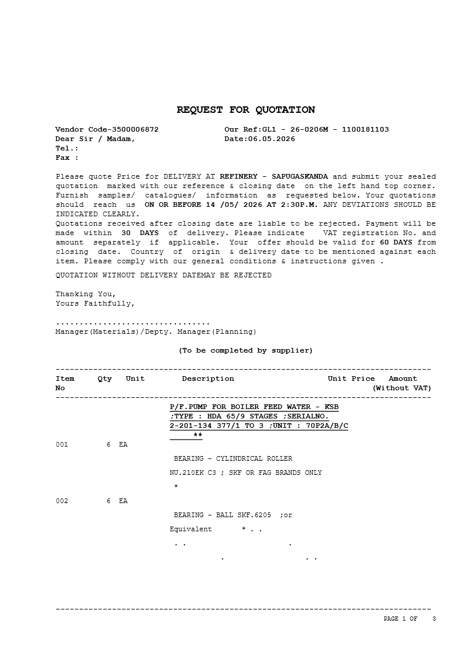
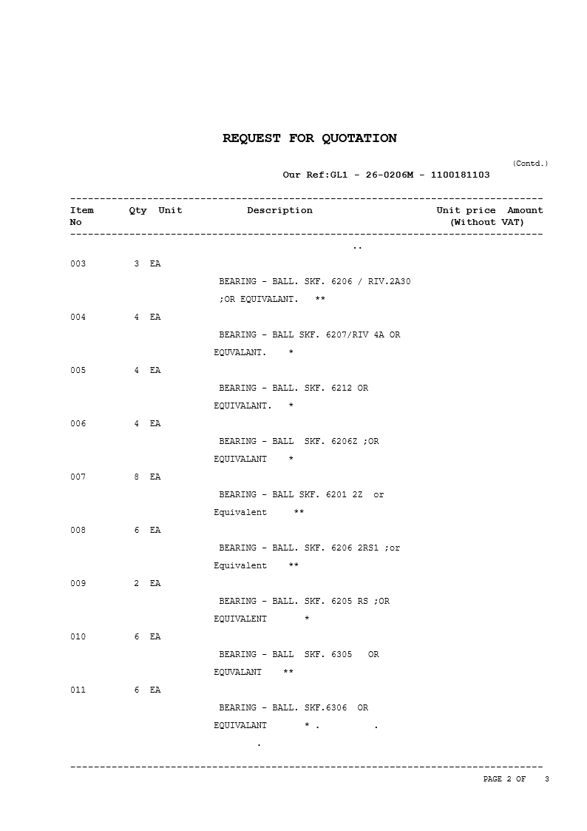
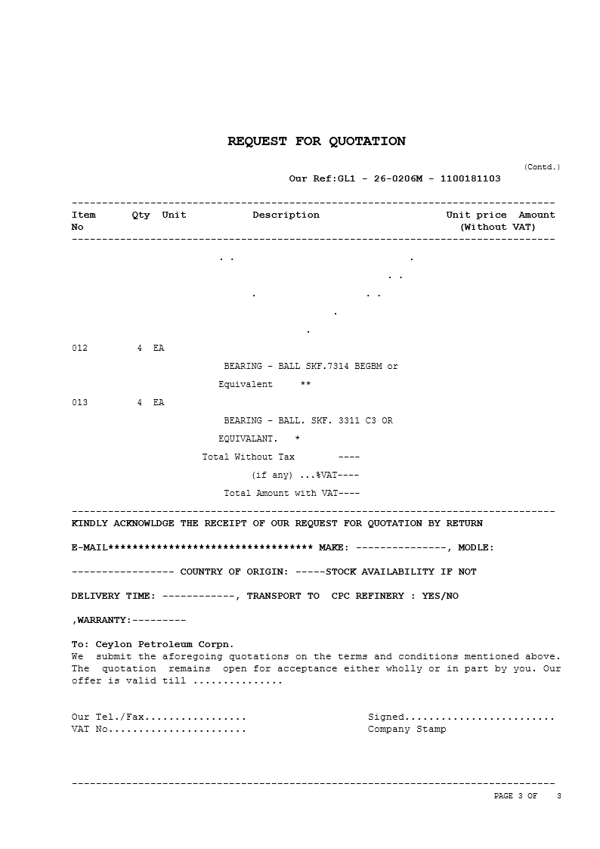

GENERAL CONDITIONS & INSTRUCTIONS
- This is only an inquiry for prices, hence should not be constructed to be an order.

- Your quotation should be sent enclosed with our reference & closing date marked on the left hand top corner of the envelope along with all supporting documents such as product catalogues

- All materials offered should have minimum of 12 months shelf life (if relevant) from the date of shipment and in any case the production date should not be older than 6 weeks from the date of delivery unless CPC has specifically specified otherwise.

- All equipment and machinery offered should be proven models and no proto-type models should be offered.
- Rates quoted should be shown both in figures and in words.

- Once accepting your quotation, an official Purchase Order will be placed by the corporation on rates quoted by you and you should ensure that goods are delivered to Refinery within seven (7) days of receiving such order if we have not stated otherwise in our Purchase Order.

- Any discounts allowed should be shown both in figures and in words.
- Basis of evaluation of quotation – Price delivered at Refinery, Sapugaskanda, (i.e. The Charges of the current CPC transport contract will be used for calculation of the delivery cost if the bidder has offered without transport charges)
- If any supplier fails to supply the goods in time at the rates quoted by them, on order placed by the corporation within the validity period of prices, such suppliers will be treated as defaulters/suspending/blacklisting them in addition to taking other actions per prevailing procedure.
- Samples must be submitted if called for

- Corporation reserves the right to accept or reject any quotation

- a) Offers should be sent only by E-mail/Post/Courier/Fax (at discretion) or deposit in the tender box at Refinery. Refinery Manager’s Office.

- Offers by E–mail can only be sent to reflocalqt@sltnet.lk (at your own discretion).

c) Only the Fax No. 2400436 is allocated for receiving offers. Offers sent to any other fax number will not be entertained.
e) However, only the clarifications data sheets, Product literature & other communications can be made through E-mail address localpurchasing@ceypetco.gov.lk / Fax. No. 0094-11-2400434/ Tel. No. 0094-11-2400110

